Horizon Cross Country Course Map
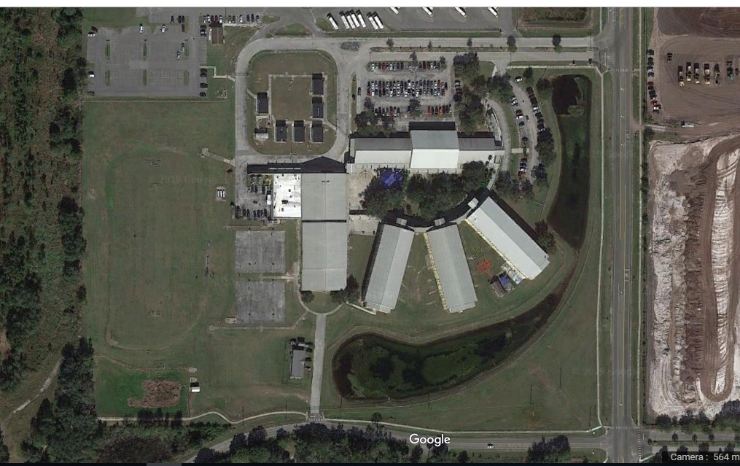
Students will complete red portion twice, on the second lap students will follow black to finish! Start and finish line is the blue line.

