FINISHH
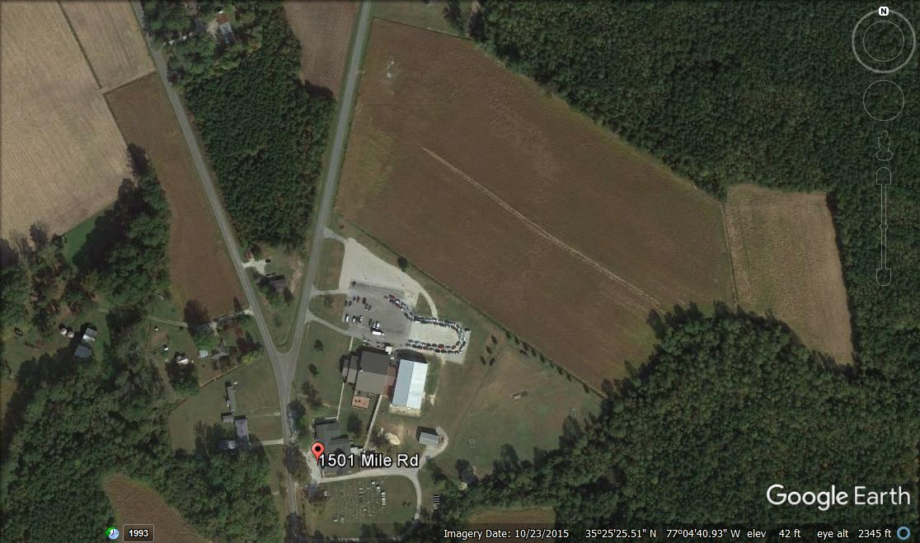
START
1 Mile
2nd Lap Turn left at soccer field

