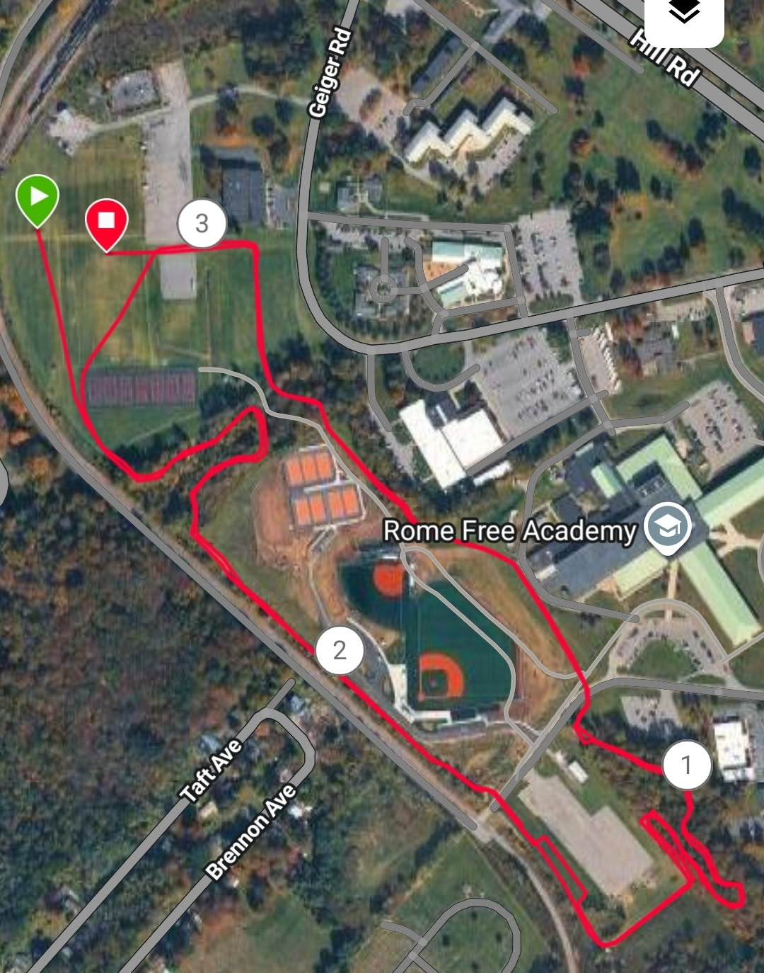
Add’l Parking
Add’l Parking
Blue Line Spectator lot 2
Tent City
Gold Line-To Bus Parking in RFA Bus circle
Bus Drop off
Loop 2 Start
Invite Meet Parking- Geiger Lot- Spectators only- NO BUS ENTRY
Finish
Start
Figure 1

