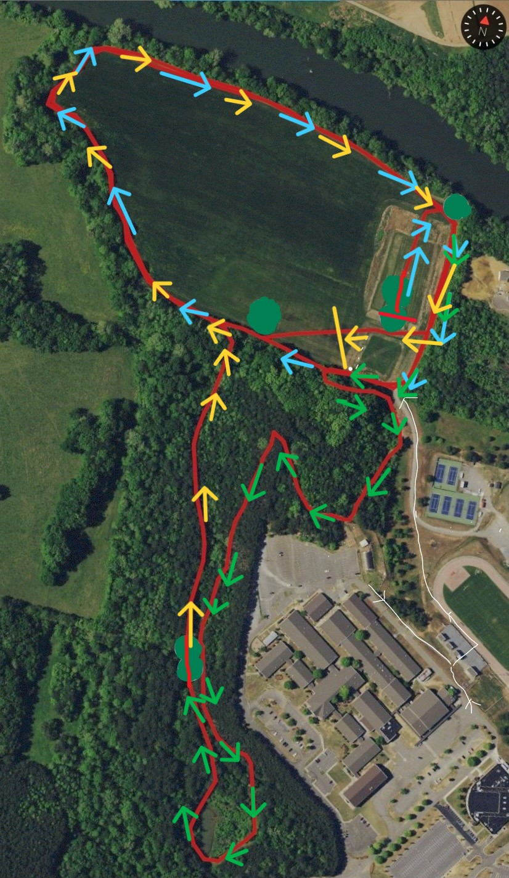
2mi
Finish
Start
1mi
High School 5K

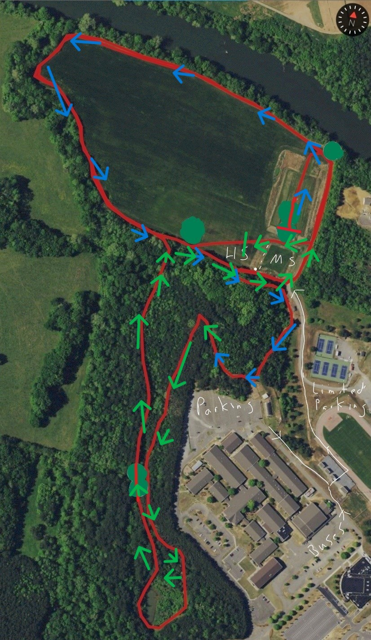
Middle School 2 mi
Finish
Start
1mi

