
2026 Class A Upper State Track Qualifier
May 9th

Abbeville
Blackville-Hilda
C.A. Johnson
Calhoun County
Calhoun Falls
Dixie
Great Falls
Green Upstate
Governor’s School
Horse Creek
Hunter-Kinard-Tyler
Lamar
Lee Central
Lewisville
McBee
McCormick
Midlands Stem
North
Ridge Spring-Monetta
Riverwalk Academy
South Carolina School for the Deaf and Blind
Thornwell
Wagner Salley
Ware Shoals
Whitmire
Willinston Elko

Class A Upper State May 9th, 2026

Schedule for Saturday May 9th, 2026 (Rolling Schedules)
10:00 AM Packet Pickup at Scoring Tower
10:20 AM Officials Meeting (Region Directors) and Check in for ALL Field Events starting at 11:00
10:30 AM Coaches Meeting with all head coaches
11:30 AM Check in for ALL Track Events

Field Events
11:00 AM High School Long Jump Girls & Boys
High School Girls & Boys Pole Vault
High School Girls & Boys Javelin
High School Girls Discus
High School Boys Shot Put
High School Girls Shot Put
High School Boys Discus
High School Triple Jump Girls & Boys
High School High Jump Girls & Boys
*Field Events will be given 4 Trials with no Finals

Running Events
11:00 AM High School Girls 3200 Meter Run
High School Boys 3200 Meter Run

Running Events – Events will be on a rolling schedule after the start
12:30 PM High School Girls 4x100 Meter Relay
High School Boys 4x100 Meter Relay
High School Girls 4x800 Meter Relay
High School Boys 4x800 Meter Relay
High School Girls 100 Meter Hurdles
High School Boys 110 Meter Hurdles
High School Girls 100 Meter Dash
High School Boys 100 Meter Dash
High School Girls 1600 Meter Run
High School Boys 1600 Meter Run
High School Girls 400 Meter Dash
High School Boys 400 Meter Dash
High School Girls 400 Meter Hurdles
High School Boys 400 Meter Hurdles
High School Girls 800 Meter Run
High School Boys 800 Meter Run
High School Girls 200 Meter Dash
High School Boys 200 Meter Dash
High School Girls 4 x 400 Meter Relay
High School Boys 4 x 400 Meter Relay

NOTE: THE ORDER OF RUNNING EVENTS WILL FOLLOW AS EACH EVENT IS COMPLETED.
*Advancement: : The Top 4 performances from Upper/Lower State will qualify automatically for the State Championships,
plus the next 8 best performances from Upper/Lower State will also qualify. Max per event at State is 16 athletes/relays.
*The javelin and discus areas are located outside the football stadium on the practice football field. Athletes participating in these events must be in uniform to reenter the gate at the stadium. Please make sure all your athletes know that they need to be in uniform at all times to enter the gate at the stadium.
*Seeding: Events will be seeded based on Times/Marks from the Region Meets Only. For Laned Events the top 8 seeds will compete in the 2nd heat.
*Parking: All Spectators will park in the parking lot in front of the gym and in front of the building. Busses will enter through the Pisgah Church Road entrance and drop off teams in the designated area near the baseball field entrance.

A Upper State Meet – WJ Keenan High School
Address: 361 Pisgah Church Road, Columbia, SC 29203
Spectator entrance
Spectator entrance

Spectator parking lot.
Bus entrance. Pisgah Church Road Gate.
Team entrance
Throwing area

GENERAL INFORMATION

ADMISSION FOR THE A UPPER STATE IS $5.00. TICKETS CAN BE PURCHASED at https://fan.hudl.com/usa/sc/columbia/organization/38271/ca-johnson-high-school/tickets

Concessions will be available.

All athletes/teams will be on the far side of the stadium or in the tent areas located on your map. The seating on the finish line side should be for spectators.

Warm-ups will take place on the field outside the stadium near the shot put area.
Infield warm-up will be limited to the present and next heat on the track.
Check-in / Clerk will be in the shed adjacent to the home-side press box.
All results will be handled live on sc.milesplit.com.
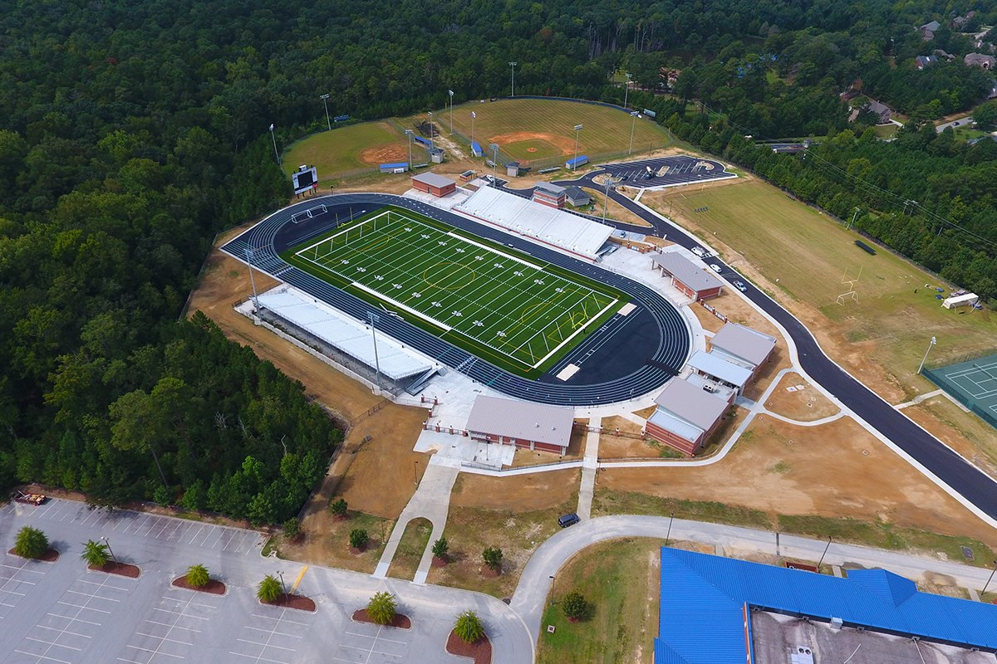
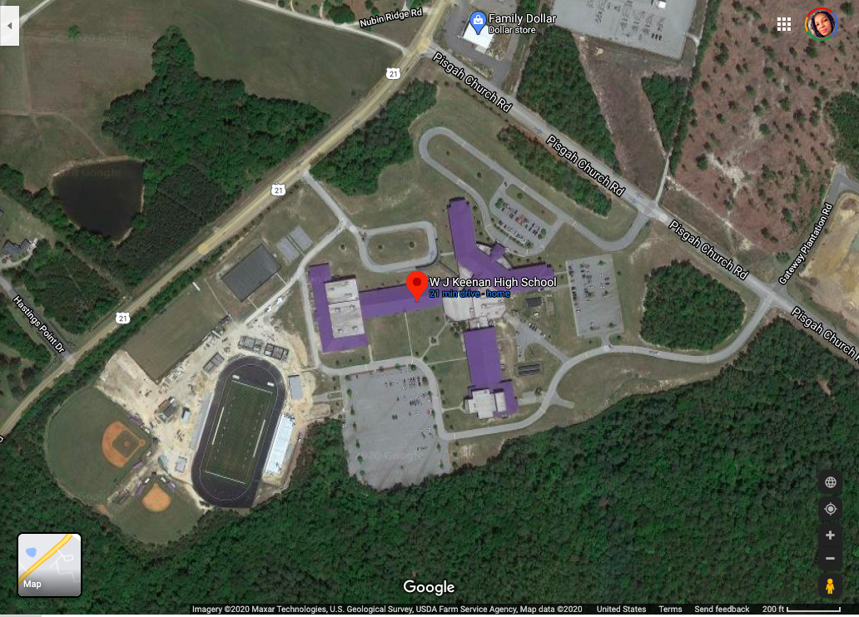

Participation and Entry Limitations

Article 2: A contestant shall not be entered in more than four events, excluding relays. If a contestant is entered in more than the allowable number of events, meet management shall scratch the contestant from the excess event(s) by following the listed order of events.

Contestant may officially enter:
Four individual events | No relays allowed.
Three individual events | May be listed on any number of relays but compete in only one relay.
Two individual events | May be listed on any number of relays but compete in only two relays.
One individual event | May be listed on any number of relays but participate in only three relays.

PENALTY: A competitor who participates in more events than allowed by rule shall forfeit all individual places and points and shall be disqualified from further competition in that meet. In a relay event, the team's relay points, and place(s) shall also be forfeited.

UPPER / LOWER MEET REGULATIONS
1. Each region track director will report all contestants in the Upper/Lower or Qualifier meet to the track directors within 24 hours of the region meet. No changes will be allowed by any school after the list has been received.
2. The Qualifying Meet Directors will secure competent officials. Meets must have a referee, exchange zone judges, and turn judges. The decision of the judges will be final. No protest will be allowed unless a violation of track or eligibility rules occurs.
3. An admission of $5.00 will be charged for Qualifying State Meets. The meet director must submit a financial statement to the League Office.
4. Upper/Lower State Qualifier (A):
Throws/Horizontal Jumps:
· There will be one flight of 12-16 athletes in each event. They will be seeded by performance from the regional meet, from worst to best.
· Each competitor will take 4 attempts.
· The top 4 performances from each site will qualify for the state championship.
· All ties for the fourth qualifying positions will be broken according to the National Federation Rule Book.
· The Meet Director will share details regarding the weighing or selection of throwing implements.
Vertical Jumps:
· The vertical jumps will be contested as normal; the top 4 athletes in each event will qualify for the state championship if they meet the minimum requirement.
Minimum Requirements:
Girls High Jump- 1.25m
Boys High Jump- 1.65m
Girls Pole Vault- 2.10m
Boys Pole Vault- 2.75m
· All ties for 4th place must be broken according to NFHS rules.
Running Events:
· In laned races, athletes will be seeded into two sections based on region meet performance from slow to fast.
· The top 4 performances per district will advance to the state championship.
· In non-laned races, athletes will be seeded into 1 section of 12-16 athletes.
· The top 4 will qualify for the state championship if they meet the required time standard (16:00 for girls, 14:30 for boys).
5. All non-laned running events will be started with a 1-turn stagger.
6. Contestants must be ready at the scheduled time of their events. If not, the Meet Director will scratch them.
7. The Upper, Lower and Qualifying Meet Directors will report their qualifiers directly to the League Office. FIRST AND LAST NAMES AND GRADE LEVELS will be used in reporting all qualifiers. Email to curtrell@schsl.org (no later than 9:00 am Sunday after your qualifying meet). Please call Curtrell Rhodan at 803-542-1147 if you are having any problems and cannot report on time.

 | South Carolina High School League  PO Box 211575  Columbia, SC 29221-6575  803-798-0120  www.schsl.org
Coach,

This form applies to the Track & Field State Series. (Region, Upper/Lower, Qualifiers & Finals)

Please read the following carefully, sign in the space provided and return to the referee immediately.

As the head Coach for _________________________ High School Boys/Girls Track team (circle one), I have discussed the following or will discuss the following with all members of my team.

- Soft single color elastic hair controlling items, excluding hats, may be worn. Must be non-abrasive. This includes headbands with one single manufacturer’s logo. Allows bobby pins, barrettes and hair clips no longer than 2 inches to be worn to control a competitor’s hair.
- Only prescription eyewear will be allowed by contestants during the competition.
- No electronic devices (i.e. cell phones, IPods, MP3 players, GPS watches etc) will be allowed by contestants in the competition area.
- My team is in a school issued same color uniform. My relay teams will report with matching uniforms of the same predominant color.
- My athletes have or will be informed of the off-limit areas.
- My athletes have been instructed about the rules and penalties for unsportsmanlike conduct. They will also be respectful to all officials and competitors.
- My athletes understand, they must check out to compete in a running event while participating in a field event. They will have 10 minutes after the conclusion of the running event to check back into the field event. If the event is a vertical jump, the event will continue as if the athlete passed each attempt. The bar will continue to move up and will not be allowed to move back down upon their return.
- My athletes understand that he/she must have competed in at least two regular season track meets prior to entering region qualifying leading to the state meet.
- If I have a vaulter, I certify that his/her weight is at or below the weight specifications of the pole.
- I will inform the meet director (prior to participation) of all athletes with special considerations, i.e., prescription sunglasses, medical bracelets, etc.

Signed ______________________________________________ Date.

This must be returned to the referee before your athletes will be allowed to compete.

