
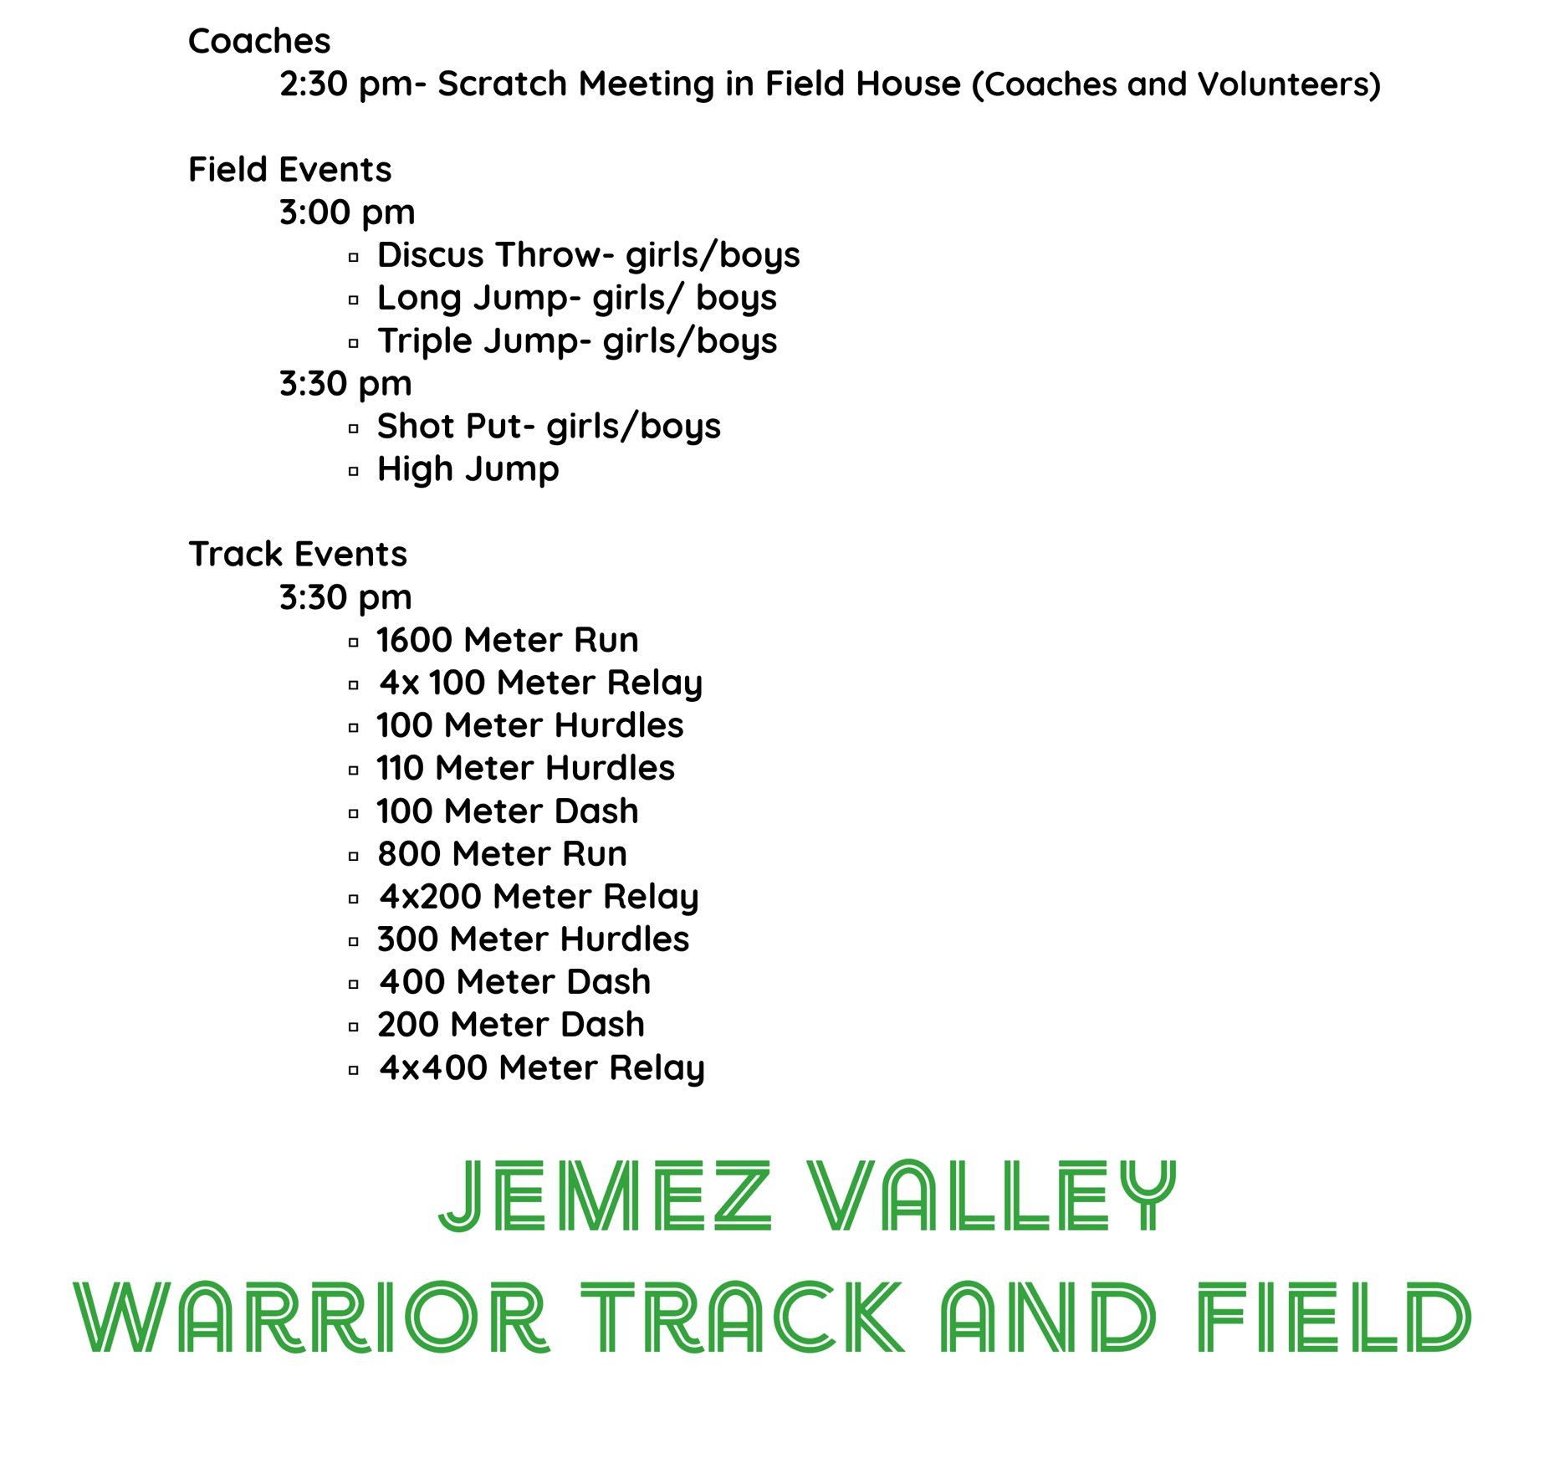
Girls/ boys
Jemez Valley Middle School
Track Meet
April 16, 2026
Steven Gachupin Sports Complex
(Coaches will be assigned to assist with a field event)

