Midwestern Athletic Conference

Track and Field Invitational
April 22nd , 2026

MAC Meet Records
Girls
100 M | Lauren Williams | Rochester | 2001 | 11.75
200 M | Tori Atkins | Laurel | 2025 | 24.48
400 M | Tori Atkins | Laurel | 2025 | 54.95
800 M | Maddie Salek | West Allegheny | 2018 | 2:14.90
1600 M | Maxine Markfield | Quaker Valley | 2003 | 5:09.37
3200 M | Kacey Gibson | Neshannock | 2007 | 11:05.30
100 LH | Layne Baggett | Moon | 2008 | 14.79
300 IMH | Maiah Yankello | Central Valley | 2016 | 44.25
400 M Relay |  | Central Valley | 2022 | 49.12
1600 M Relay |  | Laurel | 2025 | 4:05.51
3200 M Relay |  | Montour | 2022 | 9:43.63
High Jump | Delaney Sturgeon | Ellwood City | 2025 | 5’ 7”
Long Jump | Clare Ruffing | Carlynton | 2024 | 18’ 8”
Triple Jump | Noreen Johnson | New Castle | 1998 | 37’ 8 ¾”
Pole Vault | Elizabeth Michael | Beaver | 2024 | 11’ 9”
Javelin (Old) | Leanne Payne | New Castle | 1999 | 141’ 3”
Javelin (New) | Ashley Kaufman | Freedom | 2002 | 150’ 9”
Shot Put | Allyn Laughlin | Center | 2006 | 49’ 10”
Discus | Ashley Adams | Freedom | 2009 | 143’ 11”

Boys
100 M | Matt Bellay | Montour | 2008 | 10.58
200 M | Matt Bellay | Montour | 2008 | 21.79
400 M | Derek Moye | Rochester | 2007 | 49.01
800 M | Domenic Peretta | Beaver Falls | 2016 | 1:50.70
1600 M | Domenic Peretta | Beaver Falls | 2016 | 4:14.83
3200 M | Jackson Schoedel | Mohawk | 2023 | 9:24.71
110 HH | Mike Heinser | Center | 1999 | 14.02
300 IMH | Chris Rose | Beaver | 1999 | 39.22
400 M Relay |  | Aliquippa | 2012 | 42.30
1600 M Relay |  | Quaker Valley | 2025 | 3:26.25
3200 M Relay |  | West Allegheny | 2011 | 8:10.80
High Jump | Josh Jones | New Castle | 2006 | 6’ 8 ½”
Long Jump | Dante Ranieri | Hopewell | 2017 | 22‘ 10 ½”
Triple Jump | Anthony Milliner | New Brighton | 2017 | 47’ 6 ½”
Pole Vault | Josh Ghaly | West Allegheny | 2000 | 14’ 7”
Javelin (Old) | PJ Alouise | Riverside | 1999 | 208’ 9”
Javelin (New) | Noah Drudy | Hopewell | 2017 | 188’ 8”
Shot Put | Denes Veres | Riverside | 2006 | 60’ 10”
Discus | Ty McKenzie | New Castle | 1991 | 166’ 5”
MAC Track and Field Officials

Meet Directors……………………………………………………………………….…Chris Vecenie / John Montgomery
Officials: …………………………………………………………………………………… Floyd Montgomery
………………………………………………………………………………….. Gary Miller
……………………………………………………………………………………
…………………………………………………………………………………….
Field Judge………………………………………………………………………………… John Balogh
Clerk of Course………………………………………………………………………….. Devin Walsh
…………………………………………………………………………. Bill Dzurcsko
Finish Line………………………………………………………………………………….. Gingerbread Timing
Scorers………………………………………………………………………………………..
………………………………………………………………………………………. Gingerbread Timing
Meet Announcer………………………………………………………………………… Gary Lyons
Custodian of Awards………………………………………………………………….. Chris Thompson

MAC 2026
11:15 ………………………………………………………………………………………………………………………..Coaches Meeting
12:00……………………………………………………………………………..………………………………………. Events Begin

Girls Shot: (Bottom Pit Behind Scoreboard)
Flight 1: Aliquippa, Ambridge, Beaver, Beaver Falls, Blackhawk, Carlynton, Central Valley, Ellwood City, Winchester
Flight 2: Freedom, Hopewell, Laurel, Lincoln Park, Mars, Mohawk, Montour, Moon, Neshannock
Flight 3: New Brighton, New Castle, Quaker V, Riverside, Rochester, Shenango, Southside, Union, West Allegheny
Girls Disc: (Far Cage Behind Center Field)
Flight 1: Freedom, Hopewell, Laurel, Lincoln Park, Mars, Mohawk, Montour, Moon, Neshannock
Flight 2: New Brighton, New Castle, Quaker V, Riverside, Rochester, Shenango, Southside, Union, West Allegheny
Flight 3: Aliquippa, Ambridge, Beaver, Beaver Falls, Blackhawk, Carlynton, Central Valley, Ellwood City, Winchester
Girls Javelin (Far Runway Nearest the Main Road)(Grass Runway)
Flight 1: New Brighton, New Castle, Quaker V, Riverside, Rochester, Shenango, Southside, Union, West Allegheny
Flight 2: Aliquippa, Ambridge, Beaver, Beaver Falls, Blackhawk, Carlynton, Central Valley, Ellwood City, Winchester
Flight 3: Freedom, Hopewell, Laurel, Lincoln Park, Mars, Mohawk, Montour, Moon, Neshannock
Boys Shot: (Upper Pit next to baseball field)
Flight 1: Aliquippa, Ambridge, Beaver, Beaver Falls, Blackhawk, Carlynton, Central Valley, Ellwood City, Winchester
Flight 2: Freedom, Hopewell, Laurel, Lincoln Park, Mars, Mohawk, Montour, Moon, Neshannock
Flight 3: New Brighton, New Castle, Quaker V, Riverside, Rochester, Shenango, Southside, Union, West Allegheny
Boys Disc: (Upper Cage next to Shot Put)
Flight 1: Freedom, Hopewell, Laurel, Lincoln Park, Mars, Mohawk, Montour, Moon, Neshannock
Flight 2: New Brighton, New Castle, Quaker V, Riverside, Rochester, Shenango, Southside, Union, West Allegheny
Flight 3: Aliquippa, Ambridge, Beaver, Beaver Falls, Blackhawk, Carlynton, Central Valley, Ellwood City, Winchester
Boys Javelin (Runway Behind Center Field)(All weather runway)
Flight 1: New Brighton, New Castle, Quaker V, Riverside, Rochester, Shenango, Southside, Union, West Allegheny
Flight 2: Aliquippa, Ambridge, Beaver, Beaver Falls, Blackhawk, Carlynton, Central Valley, Ellwood City, Winchester
Flight 3: Freedom, Hopewell, Laurel, Lincoln Park, Mars, Mohawk, Montour, Moon, Neshannock

All throwers and jumpers will receive three marked distances. Any thrower or jumper that meets the following standards will receive an additional three throws or jumps within that flight in lieu of separate finals.
Girls Long Jump – 15’6 Girls Triple Jump- 31’6” Girls Shot Put - 29’6” Girls Disc- 86’ Girls Javelin- 91’
Boys Long Jump – 19’6 Boys Triple Jump- 39’ Boys Shot Put - 40’6” Boys Disc- 118’ Boys Javelin- 120’
MAC Jumping
High Jump: Girls then Boys – Five alive format Opening Heights (4’4 ½ ” 5’4 ½ ”)
Pole Vault : Boys (Ground level runway) Five alive format Opening Height ( 7’10”)
Girls (elevated runway) – Five alive format Opening Height (6’4”)
Long Jump: Open Pit 2.5 Hours (Boys then Girls)
Triple Jump: Open Pit 2.5 Hours (Girls then Boys)

Order of events on the track
100 / 110 M Hurdle Prelims: Top six advance to finals
100 M Dash Prelims: Top six advance to finals
4 x 800 Relay (Girls) Finals
4 x 800 Relay (Boys) Finals
100 Meter Hurdles (Girls) Finals
110 Meter Hurdles (Boys) Finals
100 Meter Dash (Girls) Finals
100 Meter Dash (Boys) Finals
1600 Meter Run (Girls) Finals
1600 Meter Run (Boys) Finals
4 x 100 Relay (Girls) Finals
4 x 100 Relay (Boys) Finals
400 Meter Dash (Girls) Finals
400 Meter Dash (Boys) Finals
300 Meter Low Hurdles (Girls) Finals
300 Meter Intermediate Hurdles (Boys) Finals
800 Meter Run (Girls) Finals
800 Meter Run (Boys) Finals
200 Meter Dash (Girls) Finals
200 Meter Dash (Boys) Finals
3200 Meter Run (Girls) Finals
3200 Meter Run (Boys) Finals
4 x 400 Relay (Girls) Finals
4 x 400 Relay (Boys) Finals
Special Thanks to Steel City Pole Vault
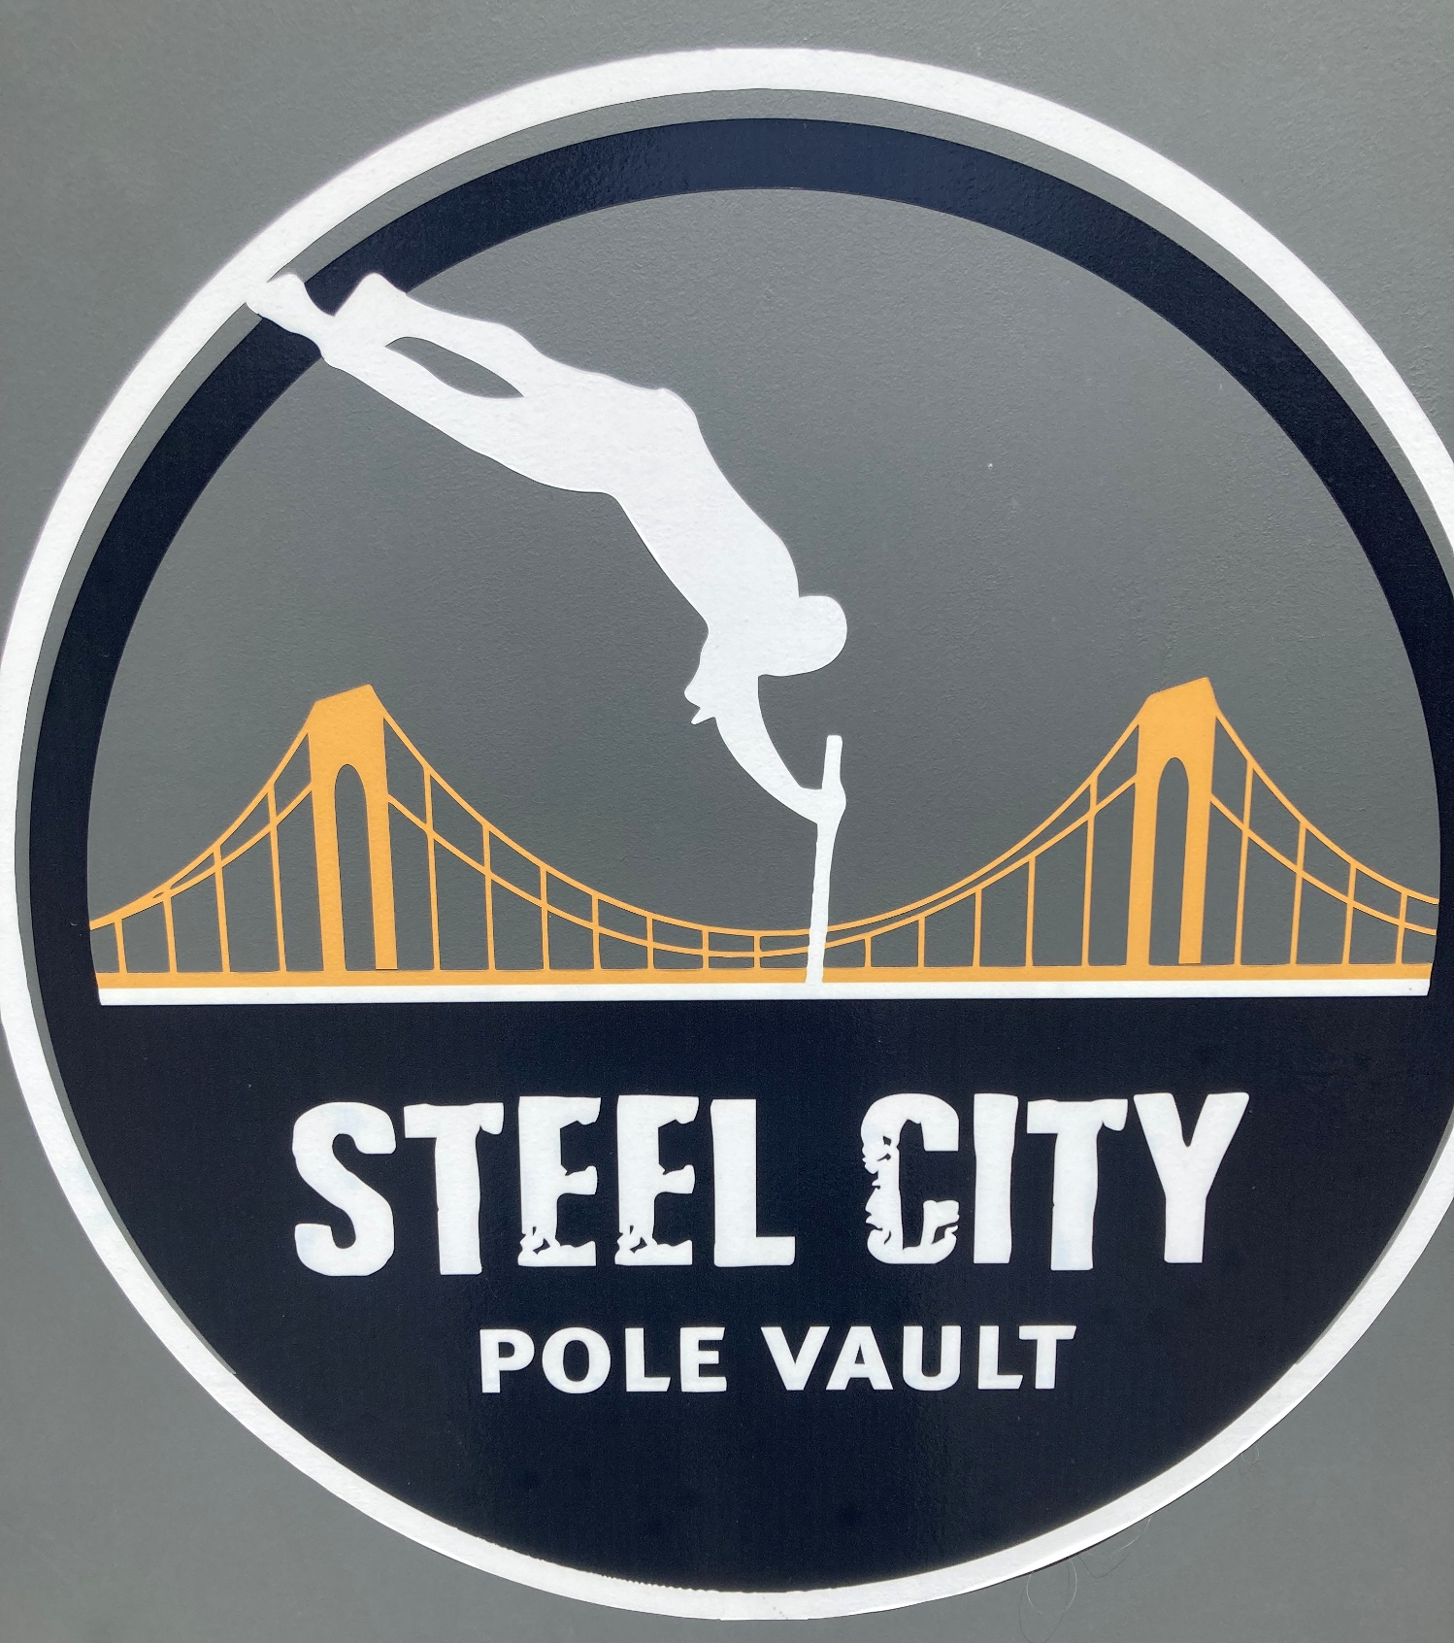
Steelcitypolevault@gmail.com 412-512-3309

