
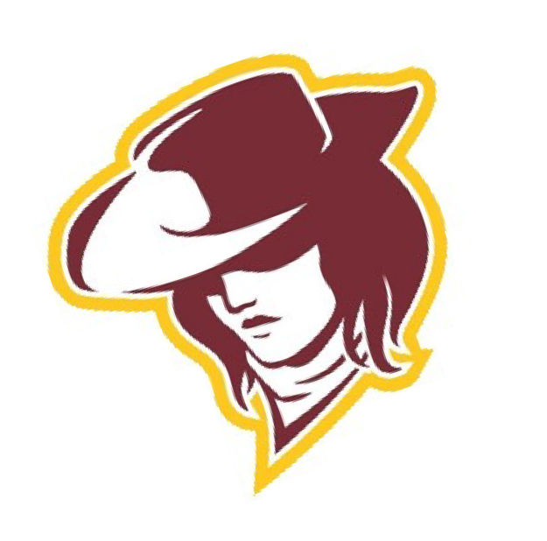

1710 Boulder Dr
Laramie, Wyoming 82070
307-721-4427
INVOICE
Date:
2/27/26
- Check
Make Check out to ACSD1 mail to 1710 Boulder Dr
Laramie, WY 82070
School


Quantity | Description | Unit Price | Total
Last Chance Qualifier at UW Fieldhouse 2/27/26
$125 per team/$7 person/Max $250
Payment | Details | Sub Total
 |  | Total

