CBISD Plan for Track and Field Events
at Griggs Field, West Columbia

- The coaches meeting will be in the indoor facility.

- There will be only scratches, no adds at the coaches meeting.

- No outside food or drinks are allowed. A concession stand will be available.
- All spectators will be seated on the Home side stands (press box side) and are required to stay on the outside of the fenced areas and behind any roped off areas around field events.
- “Team Camp” areas should be in and around the visitor side stands.
- Athletes not participating in an event or warming up are asked to stay at their designated team camp until their event check-in is called.
- No Sunflower Seeds, gum or food are permitted on the turf, track, field event, and warm-up areas.

- Gate entry fees will begin at 2:00, the cost is $5.00 for each person, CREDIT CARDS ONLY, NO CASH! Tickets must be purchased online. You can buy at the gate or ahead of time online at cbisd.com under athletics. We will honor the UIL coaching passes and senior citizen passes.

- Field events: 4 throws/jumps for varsity, 3 throws/jumps for jv boys.

- Opening heights: High Jump Pole Vault

      - Girls 4’6” Girls 7’
      - JV boys 5’ JV boys 8’
      - Varsity boys 5’2” Varsity boys 9’6”

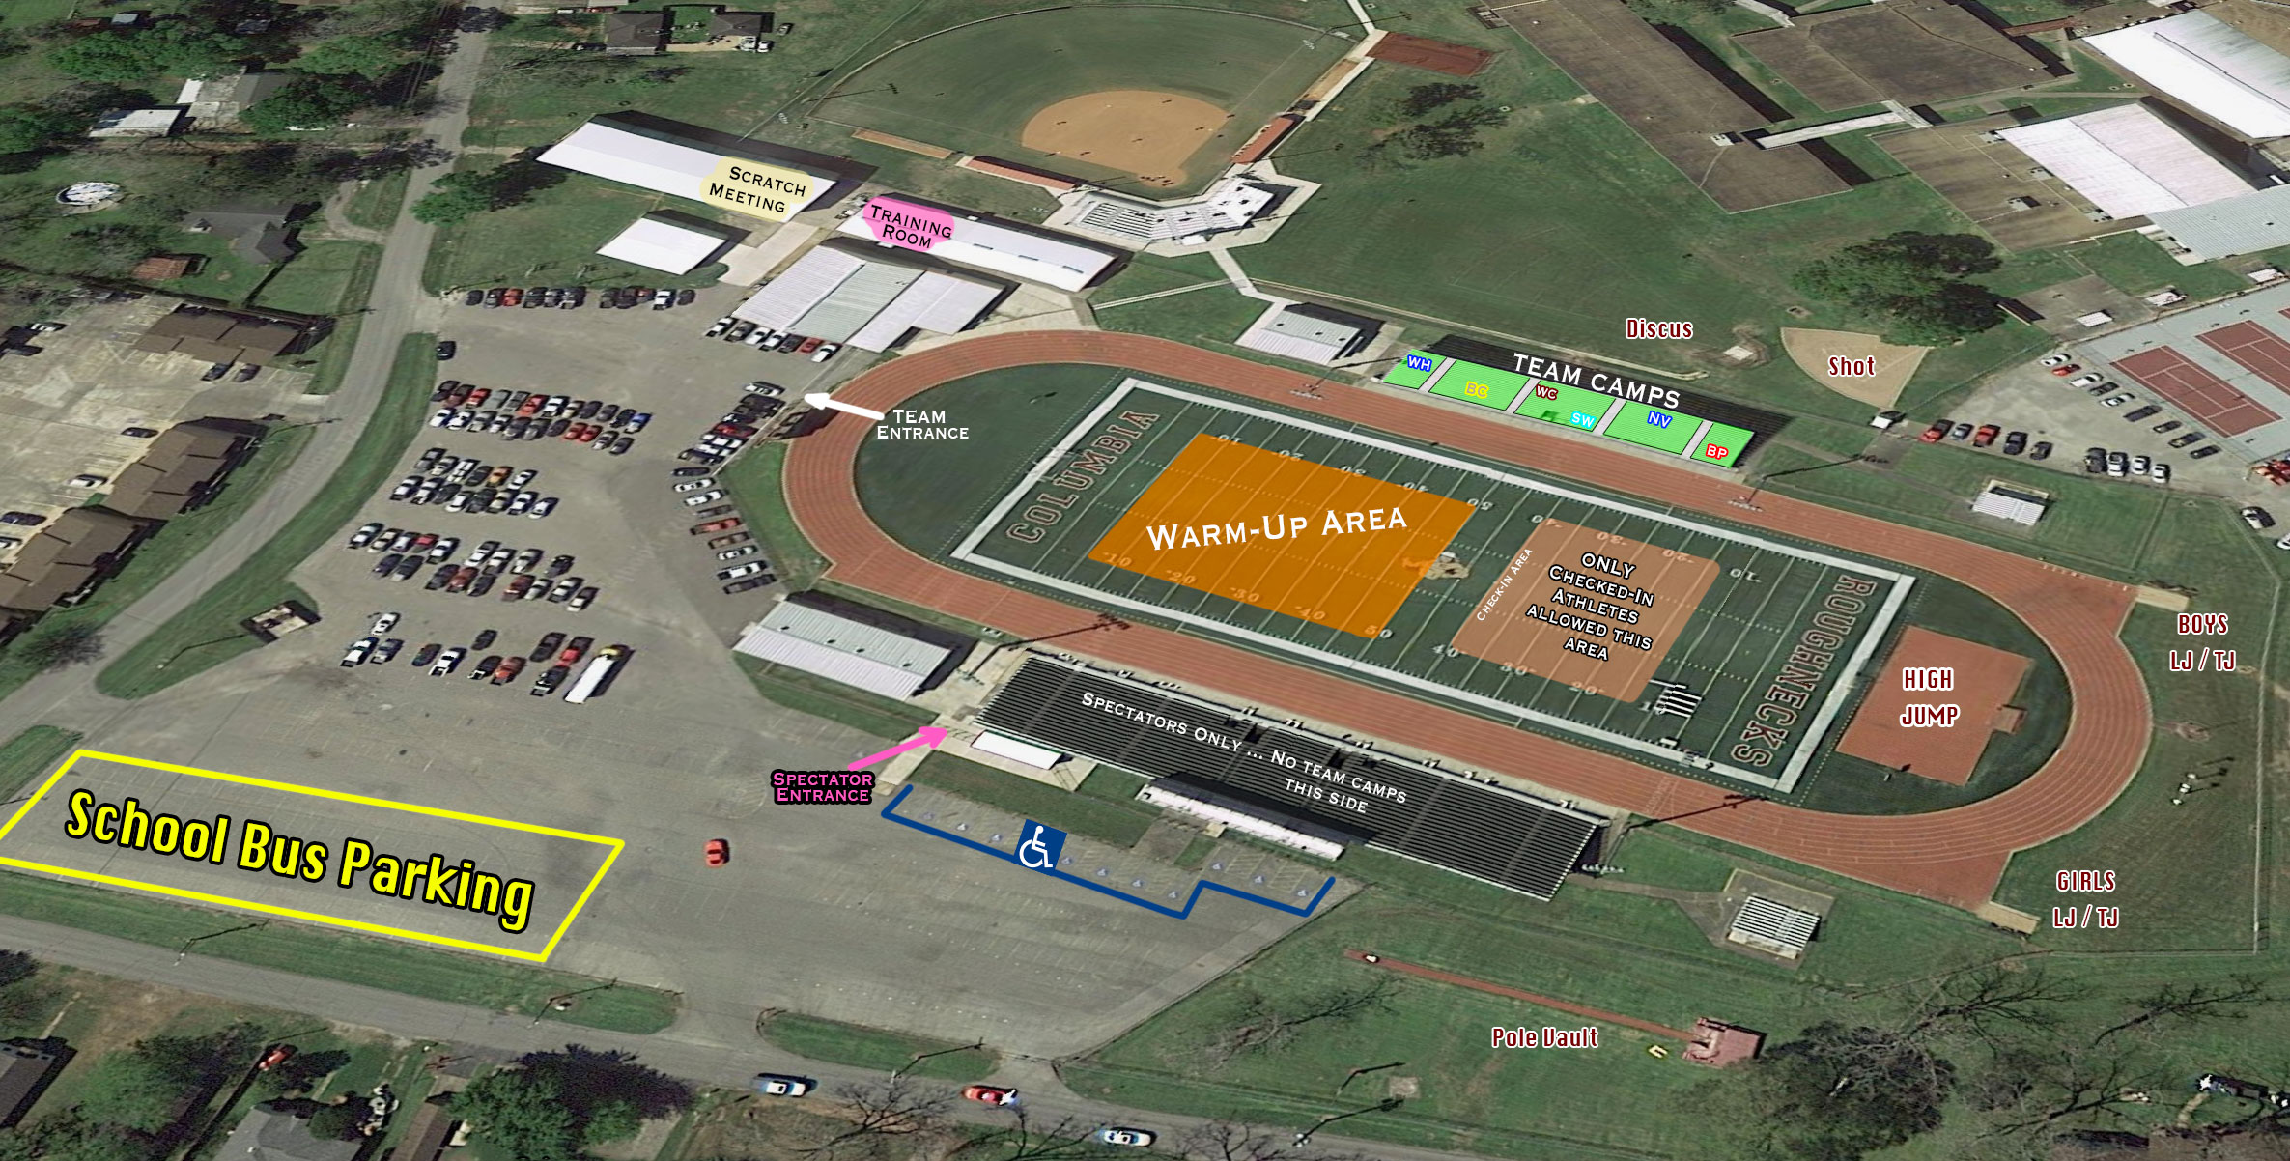
Girls Pit
Boys Pit
No Entry
All Entry
Griggs Field Complex

