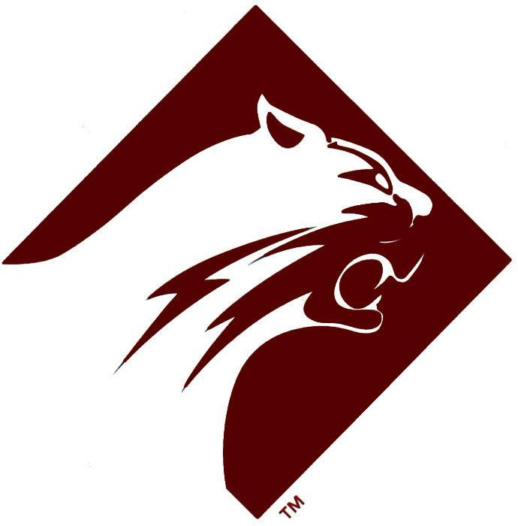
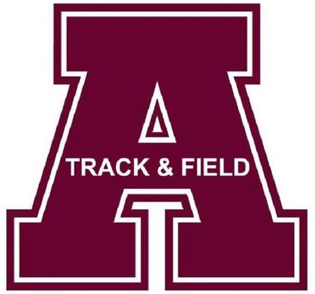
2026 Altoona Middle School
Championship Invitational

Dear Coaches & Athletic Directors,
The Altoona Area Junior High School would like to invite you and your athletes to compete in the “Altoona Middle School Championship” meet for 7th and 8th graders. Please study the information in this brochure.

MEET DIRECTOR: Mike Adams
madams@altoonasd.com
(814) 327-4408

LOCATION: Mansion Park Stadium
340 N. Logan Blvd, Altoona, PA 16602

TIME: 10:00 A.M. - Saturday, May 09, 2026

ENTRY FEE: $15.00 Per Participant (No Team Entry Fee)

AWARDS: Medals for 1st - 3rd Place, Ribbons 4th - 8th Place

PLEASE MAKE CHECK PAYABLE TO: Big A Booster – Track and Field

IN MEMO LINE PLEASE WRITE: M.S. Championship & # of Athletes Participating

**Do not mail checks. Bring them to the meet!!!!
Coaches meeting will begin promptly at 9:15 AM.

ELECTRONIC ENTRY DEADLINE - 12:00 PM - WED, MAY 6, 2025
NO CHANGES OR ADDITIONS will be made after the deadline. PLEASE DO NOT ASK!
You must meet the qualifying Standard to compete!!

Altoona Middle School Championship
Meet Regulations

1. Either flats or ¼” spikes must be worn during competition.
2. No spikes will be worn in the stands.
3. Any scratches in running events will be reported at the coaches' meeting.
4. Any scratches in the field events should be made at the event.
5. All coaches and competitors must stay in the stands. Once an athlete is finished with their
event, they should return to the stands.
6. Starting blocks will be provided.
8. Competitors must report to all events when they are called.
9. No limit on competitors. All who qualify for an event may compete.
10. Eight places will be scored. (Team points: 10-8-6-5-4-3-2-1)
11. Each participant is allowed to compete in 4 events.
12. Profanity will result in disqualification from the meet.
13. All members of a relay team should wear identical uniforms.
14. The 10-minute rule will be enforced when leaving for another event.
15. Nothing should be brought to the meet that would be disruptive, such as radios, stereos,
speakers, etc.
16. All coaches should be able to verify times and distances for all competitors if questioned.
17. Nine competitors shall qualify for the field events that have finals.
18. No Gum on the Track or the Turf.
19. Competitors and spectators are not permitted in the in-field.

BOYS: QUALIFYING STANDARDS

EVENT TIMES & DISTANCES

110 m Hurdles (33”) 19.4

300 m Hurdles (30”) 52.0

100 m Dash 12.8

200 m Dash 26.5

400 m Dash 61.5

800 m Run 2:30

1600 m Run 5:40

3200 m Run 12:25

Shot Put 34’ 0”

Discus 94’ 0”

Javelin 90’ 0”

Long Jump 16’ 0”

Triple Jump 32’ 0”

High Jump 4’ 10”

Pole Vault 7’ 6”

400 m Relay No Standard

1600 m Relay No Standard

3200 m Relay No Standard

GIRLS: QUALIFYING STANDARDS

EVENT TIMES & DISTANCES

100 m Hurdles (30”) 19.8

300 m Hurdles (30”) 55.2

100 m Dash 14.0

200 m Dash 29.6

400 m Dash 1:08

800 m Run 2:50

1600 m Run 6:20

3200 m Run 14:40

Shot Put 28’ 0”

Discus 68’ 0”

Javelin 65’ 0”

Long Jump 13’ 10”

Triple Jump 28’ 10”

High Jump 4’ 6”

Pole Vault 6’ 0”

400 m Relay No Standard

1600 m Relay No Standard

3200 m Relay No Standard

BOYS: Middle School Championship

RECORDS

EVENT YEAR NAME SCHOOL RECORD
110 m Hurdles 2017 Trey Taylor Williamsport 14.4
300 m Hurdles 2017 Byron Manchester Butler 41.9
100 m Dash 2013 Maxwell Herbst State College 11.0
200 m Dash 2025 Devin Walters Hollidaysburg 22.78
400 m Dash 2015 Quintan Barbour Chambersburg 52.4
2016 Trevor Tustin Richland 52.4
800 m Run 2018 Camron Marciniak Johnsonburg 2:07.6
1600 m Run 2024 Noah Scholnick Williamsport 4:40.39
3200 m Run 2024 Noah Scholnick Williamsport 10:11.99
Long Jump 2025 Devin Walters Hollidaysburg 21’ 4.5”
Triple Jump 2014 Brandon Clark State College 41’ 2.5"
High Jump 2017 Conrad Moore State College 5' 9"
Pole Vault 2024 Heath Miller Punxsutawney 11’ 9
Shot Put 2013 Jordan Geist Knoch 58' 9.5"
Discus 2021 Alex Polenik Penns Manor 146' 3"
Javelin 2025 Peyton Wwendell Saint Mary’s 153’ 6”
400 m Relay 2015 C. Adams, M. Hartman Altoona 46.6
K. VonCollin, M. Lawhead

1600 m Relay 2017 A. Hynoski, J. Jeffries State College 3:46.9
R. Terrizzi, S. Knipe

3200 m Relay 2011 D. Flanagan, C. Hardy State College 9:04.0
E. Heatwole, S. Plafcan

GIRLS: Middle School Championship

RECORDS

EVENT YEAR NAME SCHOOL RECORD
100 m Hurdles 2017 Jayla Bartholomew Williamsport 15.8
300 m Hurdles 2015 Audrey Hillard Butler 48.0
100 m Dash 2013 Ali Wyland Hollidaysburg 11.9
200 m Dash 2018 Nilah Foley Butler 26.0
400 m Dash 2014 Ashton McGriff Fretz 58.9
800 m Run 2019 Peyton Ellis Boiling Springs 2:20.1
1600 m Run 2024 Giselle Lindsey Cumberland Valley 5:08.42
3200 m Run 2023 Sophia Rodriguez Dallastown Area 10:17.43
Long Jump 2015 Darcy Frazier Hollidaysburg 17’ 8”
Triple Jump 2019 Brooklyn Barron Altoona 35’ 2”
High Jump 2024 Breonna Hudson Altoona 5’ 4”
Pole Vault 2023 Mackenzie Magness Freeport Area 11’ 0”
Shot Put 2024 Mikayla Fripps Cedar Crest 40’ 07.25”
Discus 2019 Justley Sharp Homer Center 109’ 11”
Javelin 2021 Mary Grusky Punxsutawney 120’ 01”
400 m Relay 2025 B Boggetta, J Sahlaney Hollidaysburg 51.45
A Horell, K Link

1600 m Relay 2017 A Altman, G Boden Butler 4:15.1
E Stewart, C Tomko

3200 m Relay 2018 A George, F Wilson Central Cambria 10:06.7
A Niebauer, S Kuntz

ALTOONA MIDDLE SCHOOL CHAMPIONSHIP TRACK AND FIELD MEET
2026 TIME SCHEDULE (Approximate)

10:00 BOYS 110m Hurdles (33') TRIALS FIELD EVENTS
10:15 GIRLS 100m Hurdles (30") TRIALS 10:00 BOYS SHOT PUT (Visitors Bleachers)
10:30 BOYS 100 m Dash TRIALS GIRLS DISCUS (Visitors Bleachers)
10:40 GIRLS 100 m Dash TRIALS BOYS TRIPLE JUMP (Flag Pole End)
10:50 GIRLS 4x8 Relay GIRLS HIGH JUMP (Scoreboard)
11:05 BOYS 4x8 Relay GIRLS LONG JUMP (Flag Pole End))
11:20 GIRLS 100m Hurdles (30") FINALS 11:00 BOYS JAVELIN
11:25 BOYS 110m Hurdles (33") FINALS
11:30 GIRLS 100m Dash FINALS 12:00 GIRLS SHOT PUT (Visitors Bleachers)
11:35 BOYS 100m Dash FINALS BOYS DISCUS (Visitors Bleachers)
11:40 GIRLS 1600m Run GIRLS TRIPLE JUMP (Flag Pole End)
12:00 BOYS 1600m Run BOYS LONG JUMP (Flag Pole End)
12:20 GIRLS 4x1 Relay BOYS HIGH JUMP (Flag Pole End)
12:30 BOYS 4x1 Relay
12:40 GIRLS 400 m Dash 1:00 GIRLS JAVELIN
12:55 BOYS 400m Dash
1:10 GIRLS 300m Hurdles (30")
1:30 BOYS 300m Hurdles (30")
1:50 GIRLS 800m Run POLE VAULT
2:05 BOYS 800m Run WEIGH-IN FOR BOTH BOYS AND
2:20 GIRLS 200m Dash GIRLS WILL BE BETWEEN 8:30-9:30
2:30 BOYS 200m Dash 10:00 – POLE VAULT BEGINS
2:40 GIRLS 3200m Run
3:00 BOYS 3200m Run
3:20 GIRLS 4x4 Relay
3:30 BOYS 4x4 Relay

