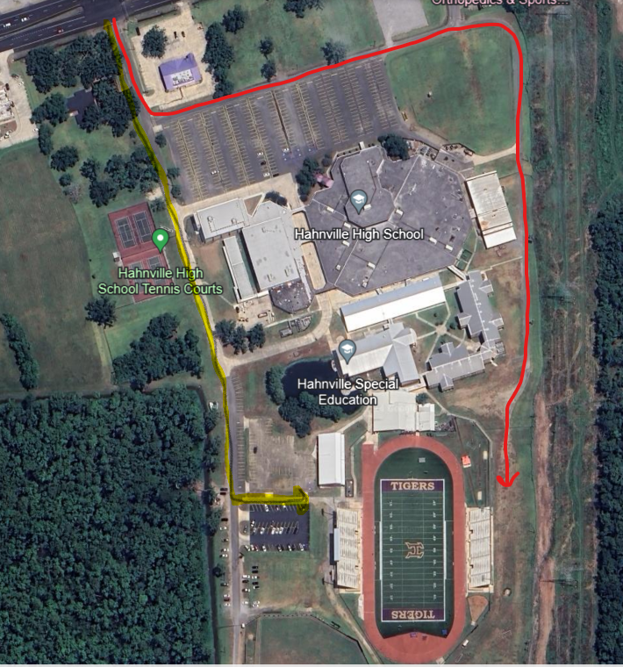
Home side of Stadium
Visitor side of the Stadium
Band practice Field
Bus Parking (Rock Parking Lot)
Yellow line is path for bus drop off to the stadium. Buses may find parking in front of school in the rock parking lot near Hwy. 90 across from the band grass practice field.
Spectators may follow the yellow line past tennis courts to the home side parking lot.
Yellow Star marks—Parking areas for the spectators for the track meet
Blue Stars marks--Additional parking in front of the school open after school lets out at (2:20PM)
Red line – old area for School Bus parking that is (No longer an option) with new alumni building in that area.
Red Star marks- and the new location of pole vault and long jump pits.
All Athletes and Coach’s will receive a wrist band when entering in the home side of the stadium (Team areas may be set up in visitor side of the stadium) Pole-vault verification forms and pole check will take place at Pole-vault pit behind the visitor side of the stadium, please bring pole vault verification form with you; all other implements will be checked in at visitor concession stand under visitor side stadium (All shots, discus, javelins)
All Spectators will enter at home side gate and watch running events from the home side stadium. Spectators may watch field events from areas marked with viewing areas with signs by each field event prior to running events. Only Coach’s and Competing Athletes may enter areas marked by signs for those field events.

