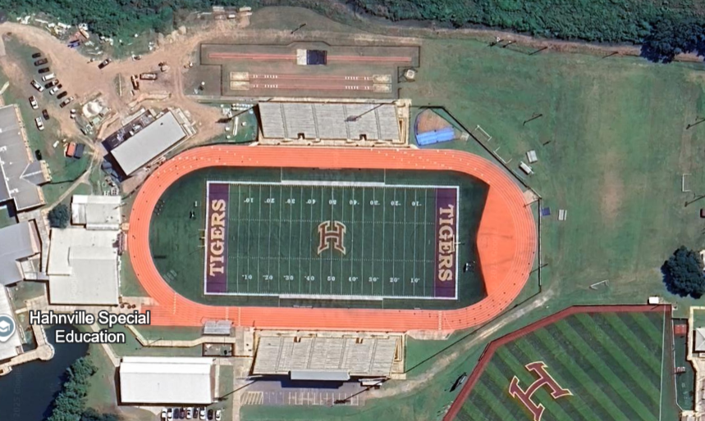
Shot Put
Javelin
High Jump
Discus
Boys Long Jump/Triple Jump Jump
Girls Long Jump/Triple Jump
Coach & Volunteer only Hospitality Room will be in the Alumni Building
Spectator Entrance (Home Side) stands for all Spectators during the running events and all concessions sold on home side of Stadium.
Signs will be at all Field events marking Spectator Viewing Areas. All Spectators return to Stands after field events, prior to start of running events)
Signs will be at all Field events for Competing Athlete’s and Coach’s Only Areas.
Athlete School Bus drop off area Parking & Athlete Entrance
(All Implement drop off & weight certification) under visitor side of stadium at concession stand
All Team set up area in Visitor Side of the Stadium
Runner Check in staging Area
Pole Vault

