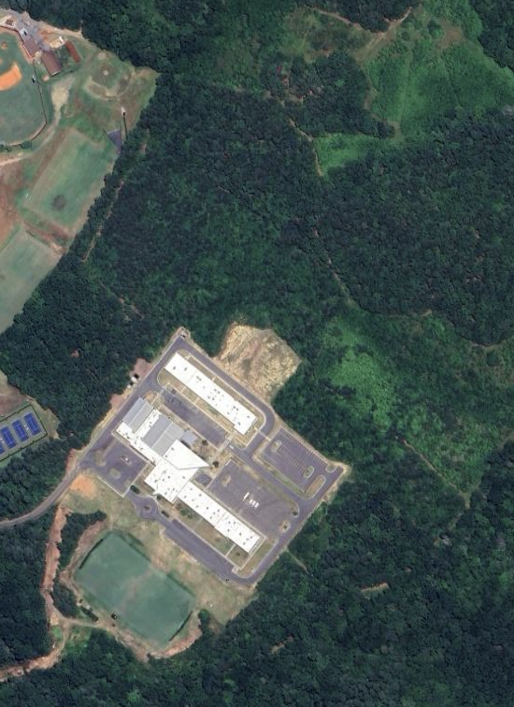
Bus Parking

Parking
Finish
Start
Start of 2nd lap

