Meet Date: Thursday, October 30, 2025
Meet Location: Ponchatoula High School, Ponchatoula
Host School: Ponchatoula High School
Meet Director: Diedra Chavers
Race Starter: Anthony Pequeno, Mandeville
Official Scoring/Timing: Ponchatoula High School/Josh Dominguez

Meet Rules Officials: Josh Dominguez
Jury of Appeals: Tim Mattei, Josh Dominguez– Ponchatoula High
Race Starting Times:
- Boys Varsity 4:00 pm
- Girls Varsity 4:30 pm
- Girls & Boys JV 5:15 pm
- Awards Presentation Directly after last race

Packet Pickup: 7:00am-7:30am
Meet Registration: All schools must register their athletes in advance online via Mile Split Louisiana

Admission: $5 – Cashless gate
Meet Entry Deadline: Registration will close at 7:00am, Thursday, October 30, 2025
Meet Entry Fee: $50.00 per gender ($100.00 for boys & girls) maximum per school; Checks should be made payable to Ponchatoula High School and brought with you to the Meet. Teams will not be allowed to compete without paying the Meet Entry Fee at Packet Pickup.

Entry Requirements: Only LHSAA registered eligible athletes are allowed to compete in this Meet. No ineligible or unattached athletes will be allowed to compete in any race.

Race Entries: Varsity 7 athletes (top 5 score)
JV - Unlimited

Race Packets: Your race packet will be available for you to pick up beginning at 2:00pm under the tent nearest the finish line. We will have a table setup for you to check in, drop off your entry fee, and pick up your race packet. Race packets will be organized by gender and school and will include your race bib numbers. Also a sheet will be in packet to indicate what athlete wears what bib number.

Timing & Scoring: Timing and scoring will be provided by Ponchatoula High School. All runners will be issued a bib number. Runners that do not cross the finish line with his/her bib intact will not be scored. A team must have a minimum of five finishers in order to receive a team score. All runners in all races must wear school uniforms with the school name clearly shown.

Meet Results: All final results will be uploaded to Mile Split immediately following the meet.

Meet Awards: Trophies for first and second place teams of each scored race; shirts for top-10 Varsity
Parking: All spectators and teams will park in the North East concrete lot of the campus. There will be no parking by the stadium. 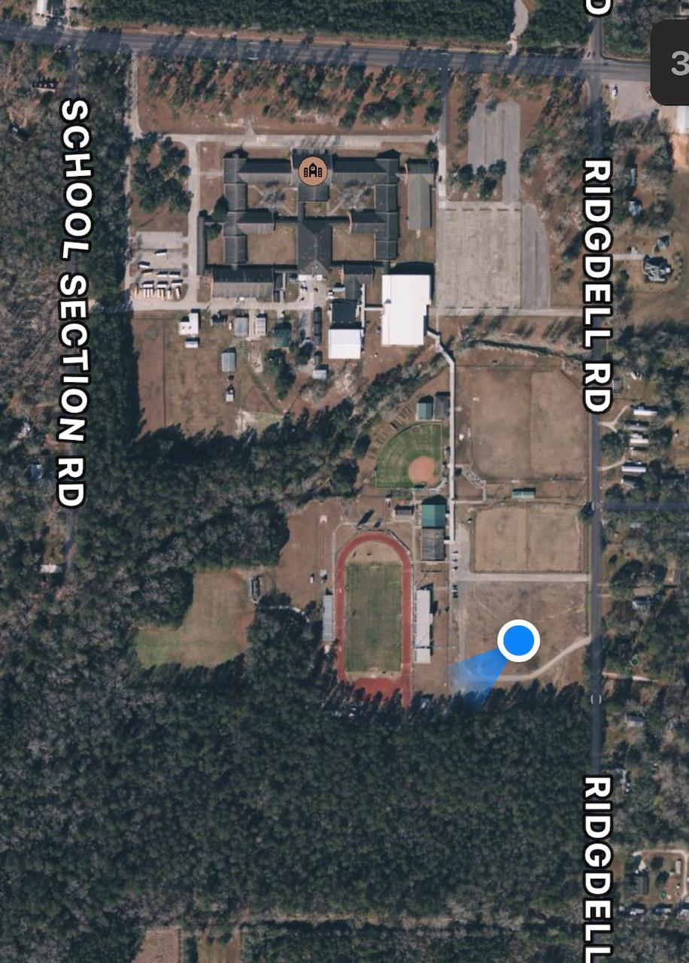
Parking
Hwy. 22

