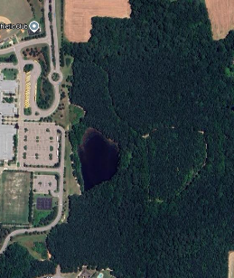
2k/4.5k
Bathrooms
Rolesville High XC Course
Special Areas
Running Direction
Distance Pole
Second Loop
Finish Line
Start Line
First Loop
Spectator
Area
5k
2.5k
1.5k/4k
1k/3.5k
.5k/3k
Finish
Start
Tent City
Tent City
Bus Parking

