Parking
Spectators
Bus Parking
Restrooms
Tents
Registration
P
P
P
P
Finish
Start
1 Mile
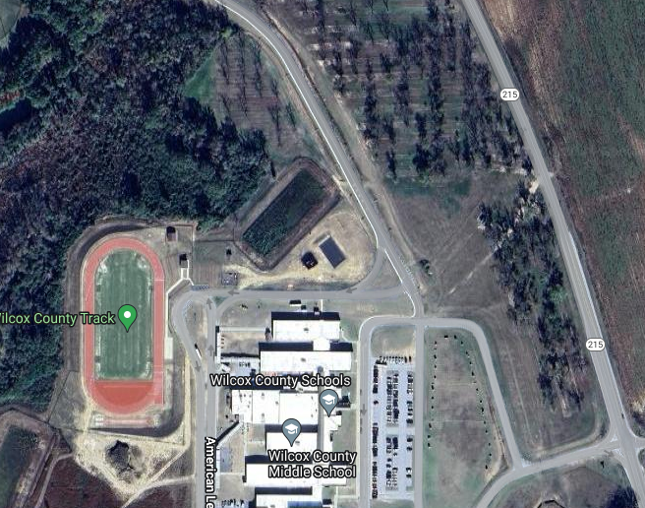
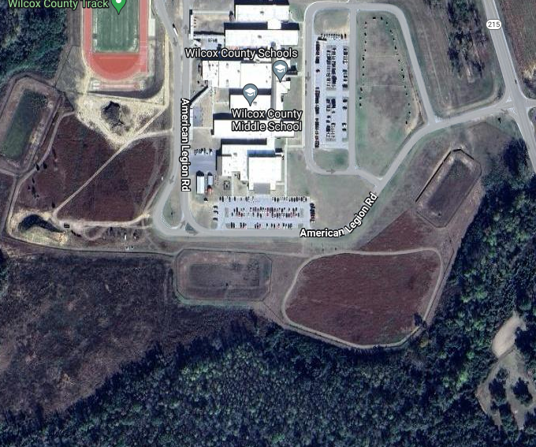

Pariking
Buses
Finish/Timer
Registration
- Trail
1
2 Mile
MS 1 Mile

