WAURIKA
Cross Country Regional
Class A, 4A & 2A
Saturday, October 18th
Location: Waurika Football Stadium 605 West Anderson St

Schedule of Events:
8:30 am Class A Coaches Meeting
9:00 am Class A Girls
9:45 am Class B Boys
Class A Awards Presentation

10:30 am Class 4A Coaches Meeting
11:00 am Class 4A Girls
11:45 am Class 4A Boys
Class 4A Awards Presentation

12:30 pm Class 2A Coaches Meeting
1:00 pm Class 2A Girls
1:45 pm Class 2A Boys
Class 2A Awards Presentation

ALL BUSES NEED TO PARK ON THE WEST SIDE OF THE FOOTBALL FIELD.

NO CAMPS IN THE BUS PARKING AREA.
COURSE MAPS

HS Girls will follow the white line the whole course. 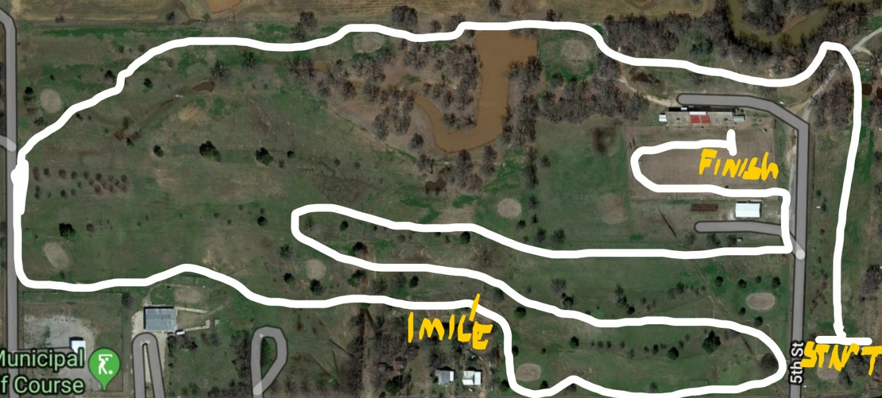

HS Boys will follow the white line then red then back to white.

