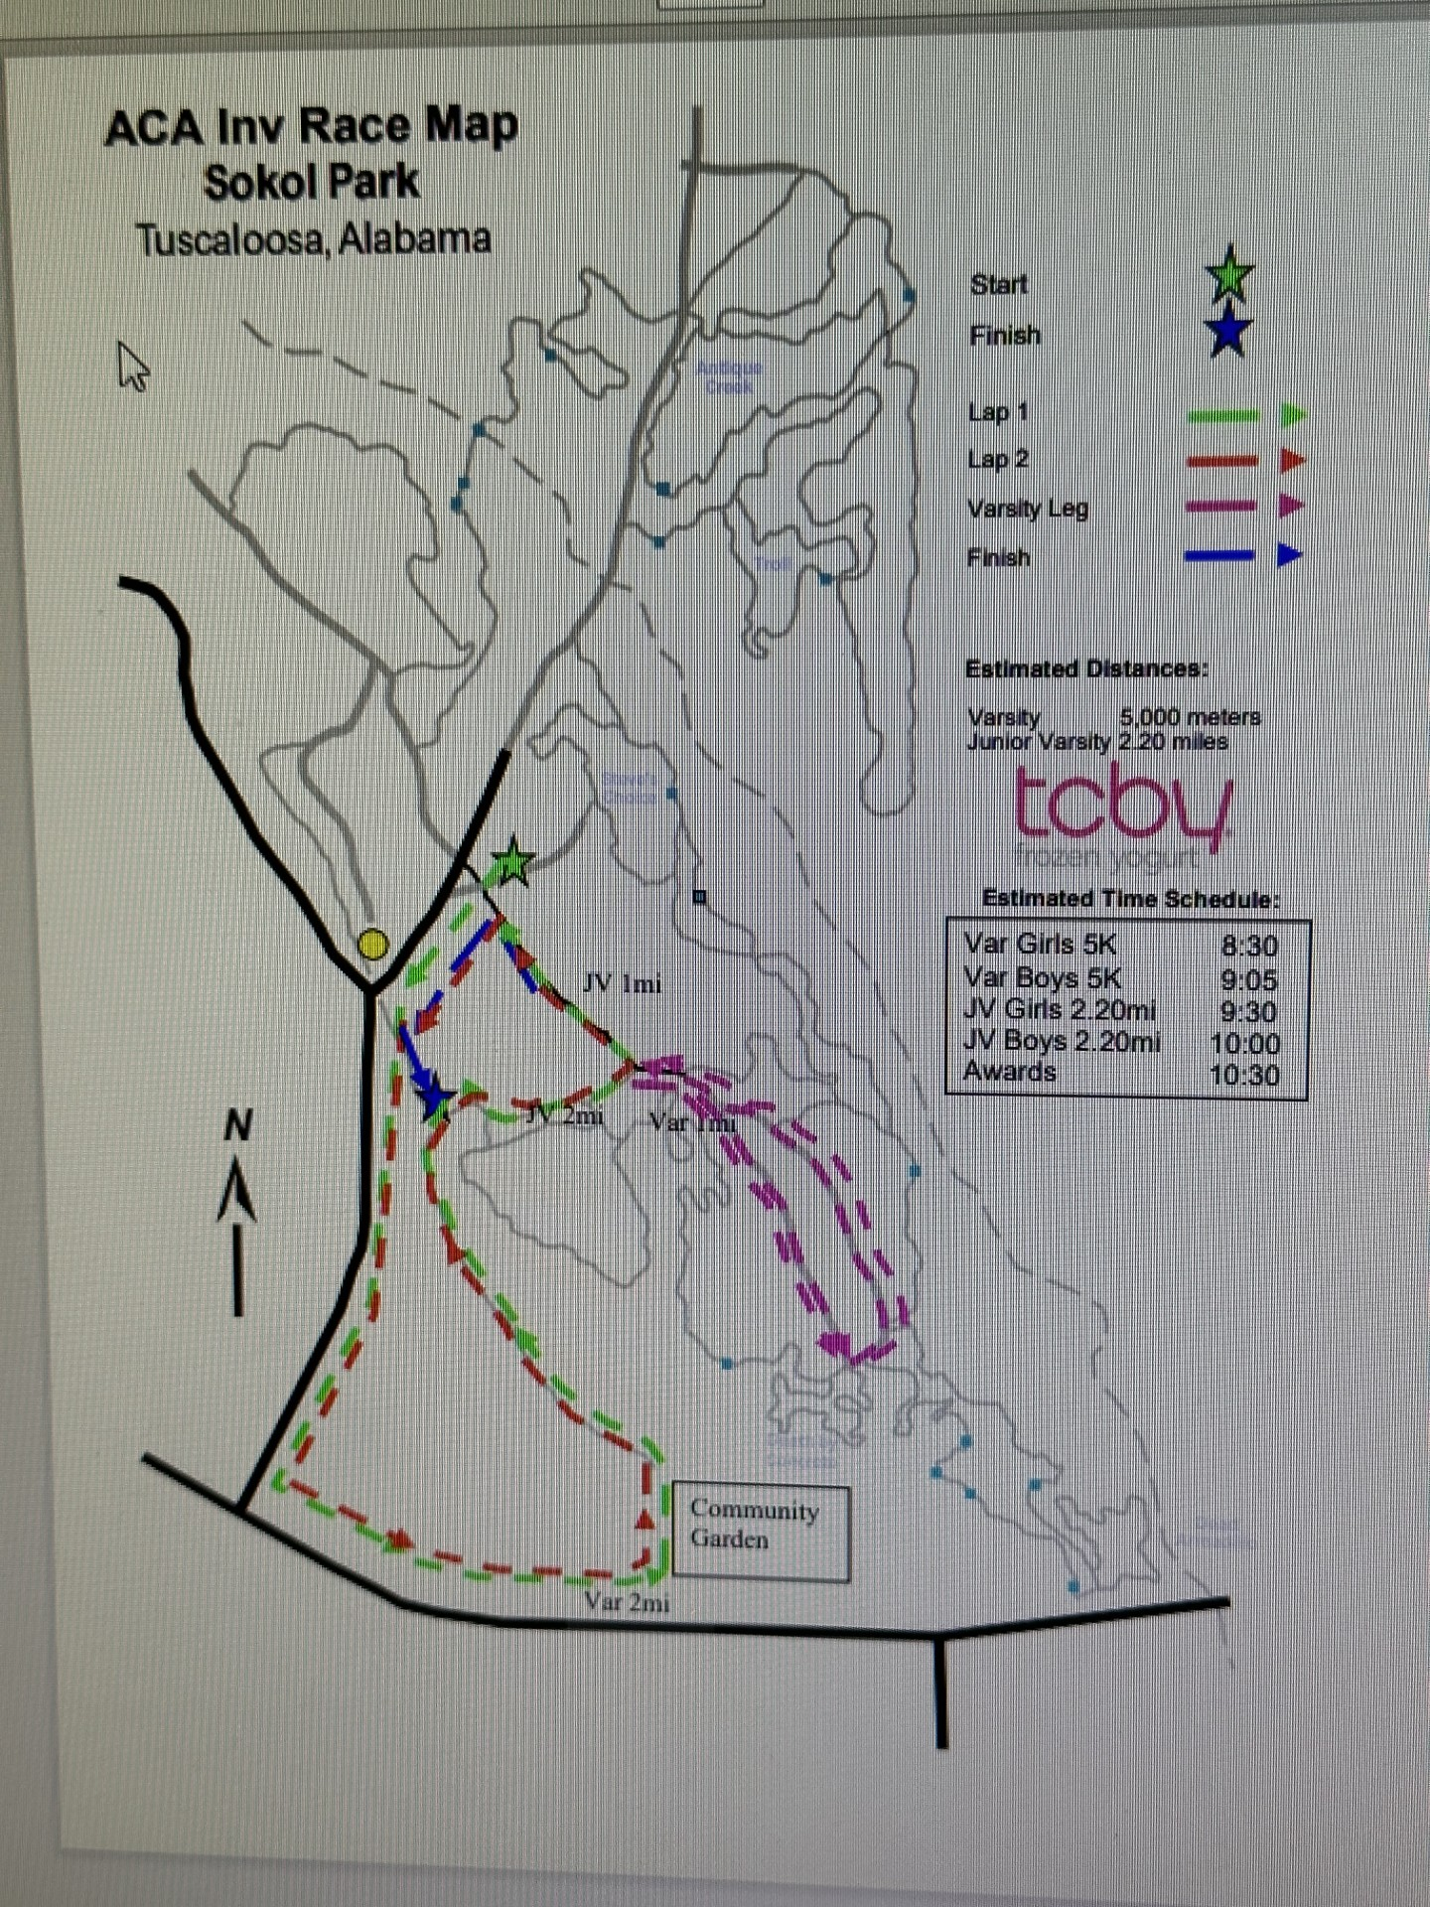

West AL & Tusc. City/Co.
MS and HS Championships Oct. 18th

Schedule :

8:00am… Varsity Girls 5K
8:30am… Varsity Boys 5K
9:00am.. Junior Varsity Girls & Boys 5K
9:30am.. Middle School Girls & Boys
(aprx 2.28 mi)
10:00am... Awards

All times are approximate.

SOKOL PARK RUNNING COURSE
T u s c a l o o s a, A l a b a m a

