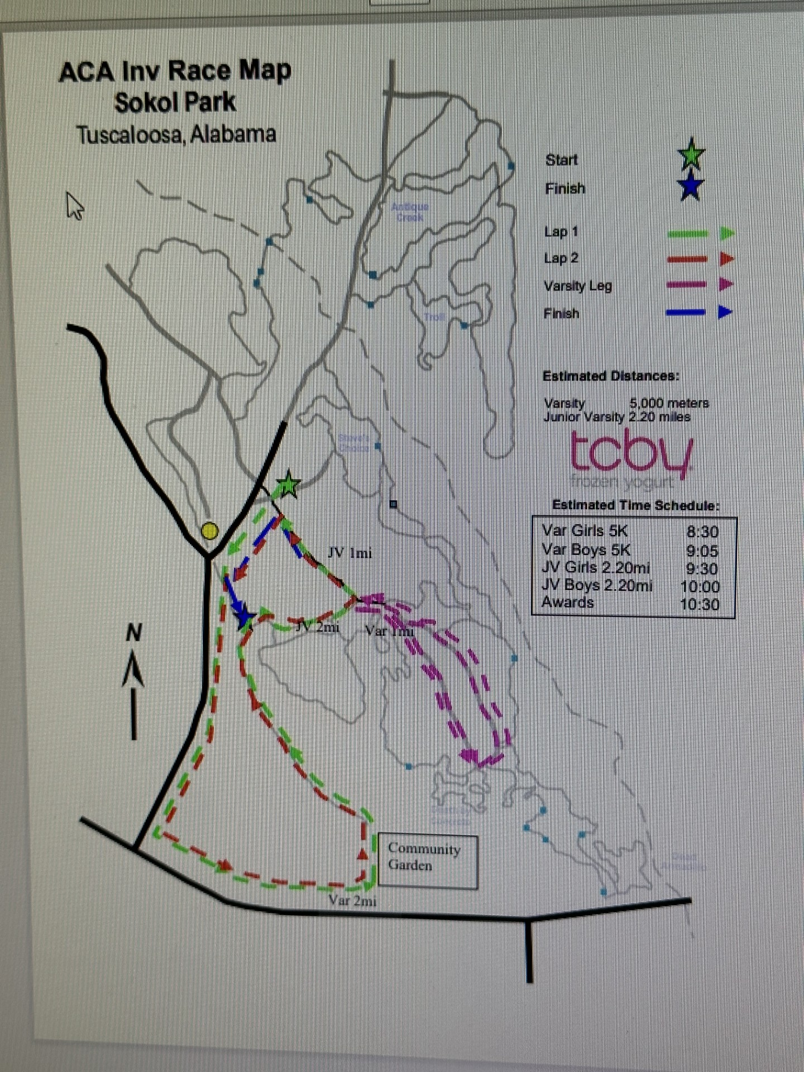
Northridge Black & Blue
Invitational Aug. 30th

Schedule :

7:30am… Open Divisions 5K
(5 year Age Group Divisions)
Open Division: Men & Women Separate (19-24), (25-29), (30-34), (35-39), (40-44), (45-49), (50-54), (55-59), (60-64), (65-69), (70-Up)
8:00am… Beginning Runners FUN RUN (approx.. 600m) Under 10
8:15am Youth 1-mile Run(10-12ish yrs old)
8:30am… Varsity Girls 5K
9:00am… Varsity Boys 5K
9:30am..Junior Varsity Girls 5K
10:00am..Junior Varsity Boys 5K
10:30am...Middle School Girls (aprx 2.28 mi)
11:00am...Middle School Boys (aprx 2.28 mi)
11:20pm..Awards

All times are approximate.

SOKOL PARK RUNNING COURSE
T u s c a l o o s a, A l a b a m a

