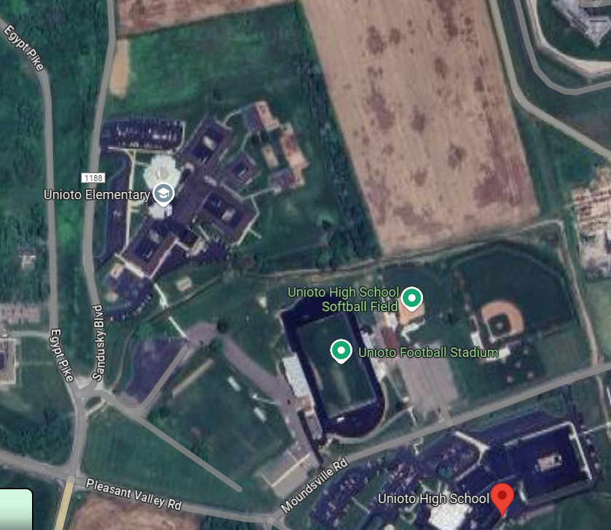
FINISH
TWO MILE
ONE MILE
START

