2025 Federal League Track & Field Championships – Information Packet
Location
Lake High School – Blue Streak Stadium (709 Market Ave. SW Uniontown, OH 44685)

Date
Friday May 16, 2025

Coaches Meeting
4:00pm. The meeting will be held at the finish line near timing trailer
Field Events
4:30pm

Running Events:
5:15pm - 4x800 (Girls/Boys)
6:00pm - All Other Running Events: see time schedule.
*No prelims, timed finals for all races. *

Entry Forms: Submit entries online: DEADLINE: THURSDAY, MAY 15th @ 10:00am
https://oh.milesplit.com/meets/686260-federal-league-meet-championship-2025-varsity-2025
*Replacements and scratches will be taken care of during Coaches Meeting prior to the meet*

Scoring:
Non-Relay events: 10-8-6-5-4-3-2-1 || Relay events: 10-8-6-5-4-3-2
TOP THREE (3) to the award podium immediately following the event.
Champions will be honored with 1st team plaques.
2nd and 3rd will be awarded certificates, printed by respective schools.

Locker Rooms
Locker Room Facilities will not be available; however, restrooms will be available.

Arrival/Drop Off Instructions
Please do not plan to arrive at Lake prior to 3:00pm. Busses should drop student-athletes off at the stadium, at our north gate entrance. Busses will then be directed to park across the street near the tennis courts. Map is included below.
Equipment
- Athletes may bring their own Shot Put and Discus to be weighed in for use.
- Starting Blocks will be available for use.
- Only ½ cut tennis balls may be used as markings on the track.
- Chalk may be used on the runways (no tape).
- Spikes of ¼” or smaller only. (Improper spikes could lead to disqualification)
Implement Weigh-in:
Implement weigh-in will take place from 3:30-4:00 pm, in the throws area track shed.
Meet Management
The meet will be timed with FinishLynx and scored using Hy-Tek. Ohio MileSplit will have Live Results.

Team Camps:
All Team Camps must be set up in the East (visitors) bleachers, or areas outside of that.
NO TEAM CAMPS IN HOME STANDS

Infield Policy
Only credentialed coaches will be permitted on the in-field. A designated warmup area will be marked off, we do not want athletes outside of the warm-up area.
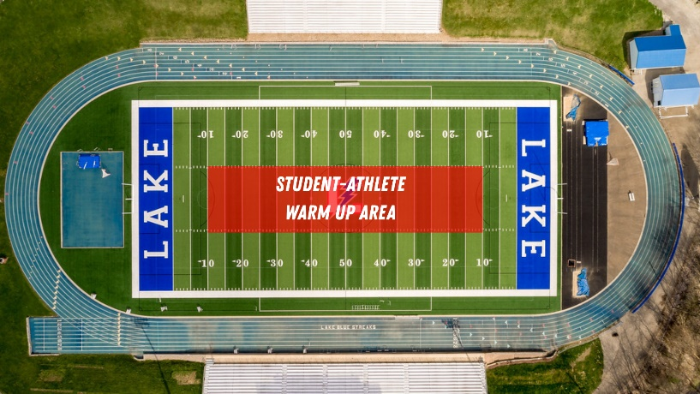

Admission (Federal League Policy):
Adults - $8 || Students - $7
Tickets are available online by using this link.
Purchases at the gate can be made with cash or card.

Hospitality
Coaches hospitality will be hosted on the second floor of the press box. Each team will be given personalized credentials for each coach to access this area. The press box will be monitored by staff to ensure only credentialed coaches are given access.

Concessions
There will be a concession stand open and a Kona Ice Truck on site.

T-Shirt Sales
T-Shirts will be available at the Second Sole Tent. Please make your athletes aware that supplies are limited.

Meet Administrators
If you have any questions, please contact
Lake Athletic Director, Brock Cline: clinebrock@lakelocal.org (330-495-7261)
Timing/Milesplit Meet Management, Ken Wolfe: wolfeken@lakelocal.org

Bus Drop-Off and Parking Instructions
