
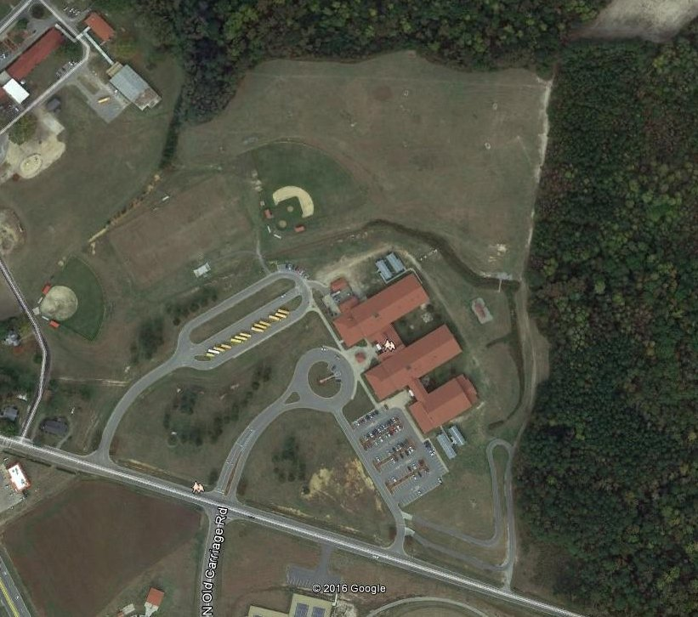
MILE 3

MILE 2
MILE 1

FINISH
Course Records
 | MEN | WOMEN
NAME | Owen Reece - Topsail | Kylee Dinterman – Currituck County
TIME | 16:46 | 21:10
DATE | 09/07/2024 | 09/07/2025

5K XC COURSE AT RED OAK MIDDLE
START

