
North Canton Hoover Facility and Ticket
Information- District Track
North Canton Memorial Stadium:
Located South of the High School off of 7th Street 525 7th Street NE.
North Canton, OH 44720

Parking and Arrival: (See Attached Parking Map)
- Please do not arrive any earlier than 2:30PM. Gate will open at 2:30PM for teams to enter.
- Buses are to drop off athletes at the should be in the LOT A (GATE A) off of 7th Street. Enter through GATE A to proceed to Memorial Stadium.
- Buses can park in Lot D.
- The closest lot to our Stadium for spectators to park is LOT A (GATE A) off of 7th Street.
- For Additional Spectator Parking, please see PARKING MAP.

Tickets:
- Prices: Adults $8 / Students $5
- Presale Tickets must be purchased online and will be on sale at OHSAA Tickets (www.ohsaa.org/tickets)
- Cash ticket sales ONLY at the gate.
- Gates open 45 minutes prior to first event start time
- No passes are accepted.
**Children age 5 and under are FREE with paying adult.
Spectator and Stadium Reminders:
- Concessions are available.
- Pets, Alcohol, Tobacco, and Vapes are prohibited.

Athletic Trainer and Water:
- Athletic Trainer will be on site.
- Water will be provided
- Teams are asked to bring their preventative training supplies (tape, pre-wrap, etc.).

Parking Map:

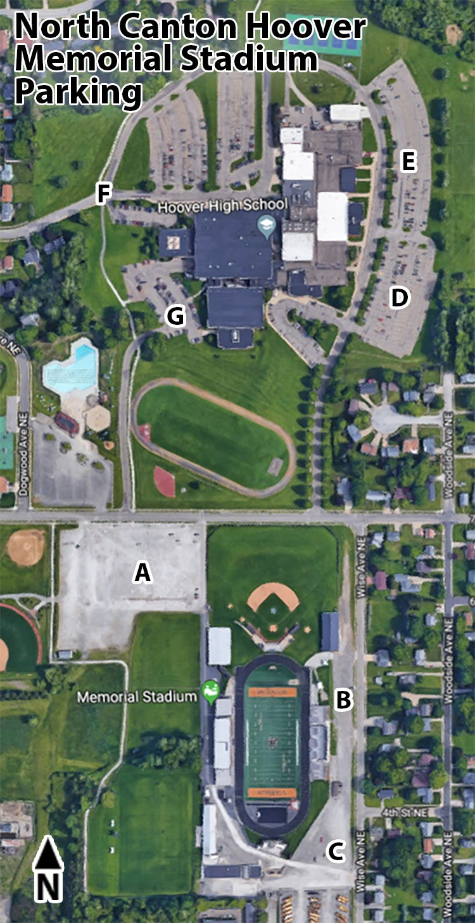

Spectators can park in LOTS A, B, C, E, F

