AHSAA 1A Section 2, 2A Section 2
Track & Field Championships April 25-26, 2025

Hosted By: Loachapoka High School, 685 Lee Road 61, Auburn, AL 36832

1A Schools: Alabama School for the Deaf, Autauga Academy, Autaugaville High School, Billingsley High School, Breakthrough Charter School, Ellwood Christian Academy, Fayetteville High School, Francis Marion School, Jefferson Christian Academy, Maplesville High School, Notasulga High School, Victory Christian School, Winterboro High School

2A Schools: Cornerstone Schools of Alabama, Green County High School, Holy Spirit Catholic School, Horseshoe Bend High School, Isabella High School, Lafayette High School, Lanett High School, Loachapoka High School, Reeltown High School, Tuscaloosa Academy, Vincent Middle High School

Verification: A printed copy of your entries will serve as your verification of entry into the meet.

Packets: Packets will be handed out at the coaches meeting Friday. Athletes and Coaches must wear armbands to be admitted to the facility. Teams will receive 3 coaches meal tickets per day in your packet. Coaches and athletes must wear their armbands both Friday and Saturday. Do not remove them until the meet is OVER on Saturday.
Uniforms: Athletes must meet uniform rules. Please make sure your relay teams are legal.

Gate: Ticket admission is $10.00 per person Friday and Saturday, cash or purchased on GOFAN.
Day 1: https://gofan.co/event/3558347?schoolId=AL11749
Day 2: https://gofan.co/event/3558353?schoolId=AL11749
Protest Fee: A $25.00 cash protest fee will be required for any objections to the meet referee’s decision. This includes all rereads on finish photos. Any appeal must be given to the referee in writing accompanied with $25.00 within 30 minutes of infractions. If appeal is upheld, the money will be refunded. Appealable offenses are misapplications of NFHSA rules. Judgment calls cannot be appealed.

Jury of Appeals: We have a meet referee, but each classification will also have a jury of appeals consisting of three coaches from schools in a different classification.
- Jury of Appeals for 1A w/2A Coaches: Horseshoes Bend, Lanett, Tuscaloosa Academy
- Jury of Appeals for 2A w/1A Coaches: Autauga Academy, Jefferson Christian Academy, Maplesville High School

Relay Exchange Zone Judges
Relay zones will be judged by coaches from different classification as follows:

4 x 100 Meter Zone Judges for 1A Coaches
- Zone 1: Cornerstone Schools of Alabama, Lafayette High School
- Zone 2: Holy Spirit Catholic School, Tuscaloosa Academy
- Zone 3: Isabella High School, Green County High School

4 x 100 Meter Zone Judges for 2A Coaches
- Zone 1: Billingsley High Schools, Fayetteville High School
- Zone 2: Ellwood Christian Academy, Maplesville High School
- Zone 3: Jefferson Christian Academy, Winterboro High School

Team Area: Teams will set up tents on the sidelines of the football field. No tents will be allowed in the stands or on the field.

Throwing Venues: All throwing events will take place on the perimeters of the track. Javelin is located across from the football field.
Parking: Parking for buses will be in the designated parking lot in front of the football stadium. Once parked athletes can unload and enter the football stadium.

Athletes Entry: Athletes will enter the track from the football field. The infield of the track is CLOSED to EVERYONE. No athletes will be allowed in the competition area unless they are competing. The middle of the football field is the designated warm-up area for athletes. Absolutely no electronics of any kind are allowed in the competition area. Please ensure that when your athletes report in, and they are ready to compete.

Minimum Qualifying Standards from AHSAA: https://docs.google.com/document/d/1FgbohQMzLK8iU9r5qi0xGaMKbLDfwbINaUGyPr-qysI/edit?tab=t.0

Pole Vault Verification: Here is the link to print
https://docs.google.com/document/d/1iTMtnZ4rKvUTqIqoHsmoLWoOA3ZXYkqcQM3S1sPsMAs/edit?usp=shar

Open the link below to print off Relay Cards for 4x100, 4x400, & 4x800 Relays
Relay Cards https://docs.google.com/document/d/1o-kO96MvJkve9v5dZlF5ifUsf6jx547unwdIYKcnbDc/edit?tab=t.0
Click to download a Copy of W-9: Please add on line 1 of the W-9 next to Lee County Board of Education, Attention: Loachapoka High School Track
//assets.sp.milesplit.com/meets/678929/files/w-9_2024_(1)_(1).pdf

Contact Meet Director: Sabrina Milligan (Cell) 334-728-2707, milligan.sabrina@lee.k12.al.us
Loachapoka Track & Field Facilities
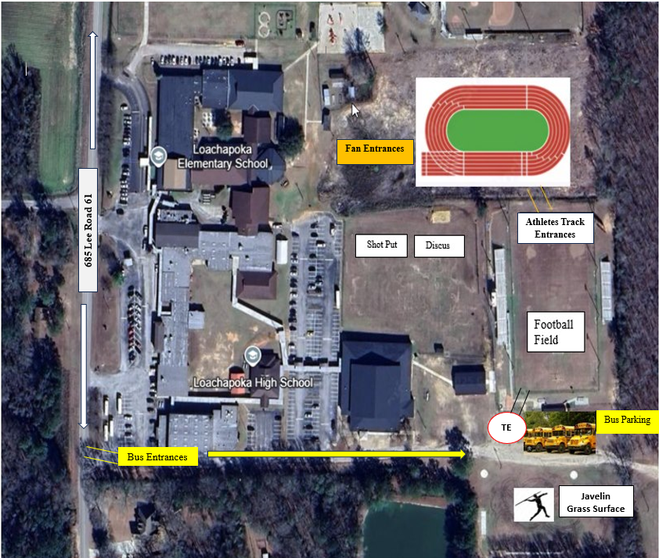

TE: Team Entrance

