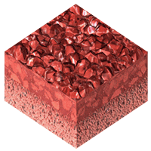
BSS 1000
Wayne Track
Overview
Technical
Featured Installations

Performance Series
The BSS 1000 system, our most popular system, offers a bio-engineered force-reduction layer integrated with fine SBR rubber granules to create an impermeable shock-absorbing cushion. With 29% more two-component polyurethane than competing systems, our performance line delivers optimal shock absorbency and superior energy return.
World Athletics Certified
Yes
Bond to Substrate
Chemical
Textures
Embedded, Encapsulated, Hobart
Performance
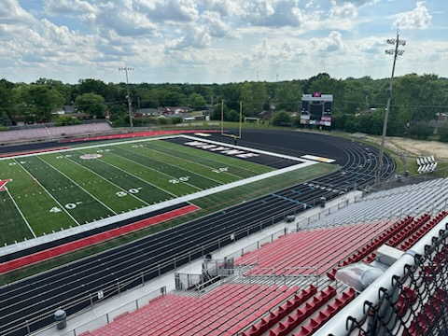
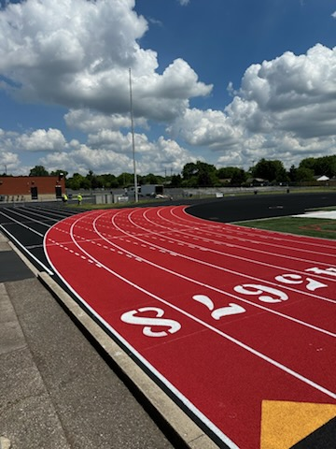
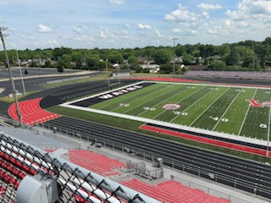
4.5-star
