NCS XC Course October 10, 2023
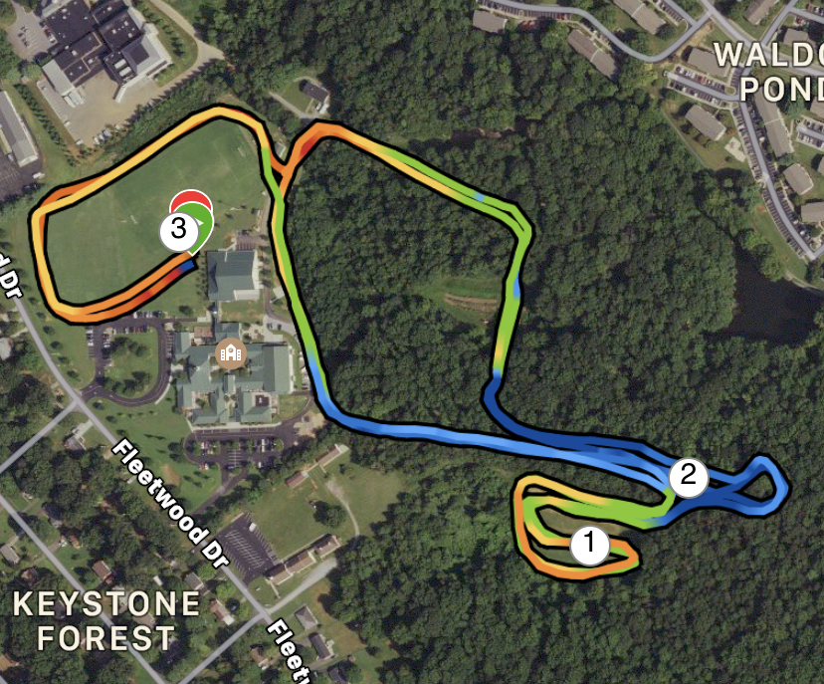

- Start and Finish Line is in area beside Workman Fieldhouse and soccer fields
- Loop soccer fields and take left past garage on gravel road
- Take right at house onto established dirt road
- At 4-way junction take right to go downhill leading toward retention pond dam (pond area is dry)
- Cross the dam and take a left on path 2/3 up hill
- The wooded path will loop around until directing runners through a joint path (separated by flags) and into the Serpentine (big open field)
- In the Serpentine, run the established, mowed grass path until returning to woods at point of entry
- Climb dirt road up until exit to right at fire hydrant/garden/playground (wooden fence on your right)
- Veer to the right and run by/on road past the Moomaw Gym and downhill by Greek Steps/play area/shed
- Near the corner of the soccer field (above you) is the ½ way point of 5K race – 3K race goes immediately up to soccer fields
- Varsity will run the entire loop in the woods a second time
- When you return to that point past the Greek Steps/play area/shed, you will run up onto the soccer field backwards from when you started – past garage, around fields to the Finish Line

One Loop through woods is 3K course = 1.87 miles.
Two Loops through woods is 5K course = 3.1 miles. (Pic shows 3 miles, but it’s 3.1 rolled in middle of path.)

1-Mile Mark is in the middle of the Serpentine.
2-Mile Mark is just prior to Serpentine on the second Loop.

