

District 24-AAA Track Meet Information

District 24-AAA Athletic Directors and Head Track Coaches,
Attached are the District Meet Schedule along with workers list and responsibilities for each school and other pertinent information. Please get this information out to all those involved. Athletic Directors please make sure you have all your necessary workers on time and at the meet both days as necessary to cover the events and areas your school is responsible for working.
Each school needs to bring all necessary equipment to run off their field event other than bigger needs. (rakes, broom, pole vault extension bar, curb flags, etc.) Timers need to have a stopwatch. AD’s please be present on both days if at all possible as we make up the games committee.
A meal will be provided for coaches and workers in the gym on Wednesday for lunch. Thursday’s coaches and workers meal will be provided by our Booster Club through the concession stand.
AD’s, I need a headcount by April 5, from each school, how many coaches and workers you will have working on Wednesday and Thursday if different so we can be prepared to have you all fed.
With today’s technology, we no longer see a need to have a scratch meeting prior to the first day of the meet. All entries will be submitted through Mile Split with seed time and heat and lane by our neutral party responsible for running the FAT system. Any scratches will be made at the scratch meeting on the morning of the 13th. Opening heights will be decided at that time as well.
Track Coaches:
If you want to feed your athletes, one or both days, the cost will be $8.00 per athlete, per day. Please make checks out to East Bernard Athletic Booster Club. I will need your number of meals you need for each day emailed to wade.bosse@ebisd.org by 3:30 on Wednesday April 5.
Make sure you have all UIL forms filled out and signed and email to wade.bosse@ebisd.org your district entry form by April 7 (5th day before meet). Make sure every varsity athlete you intend to enter in the district meet is on this entry form as well as your eligibility form which is on file with the DEC.
Our District Meet on Mile Split is already open to submit your entries. Help with Mile Split if you have not used is attached to this email. Entries are due Friday April 7 by 6:00 P.M.

Coach Bosse – 979-215-1132 wade.bosse@ebisd.org

2023 District 24-AAA Track & Field Meet
Event Workers List
High Jump – Hitchcock Shot Put – Hempstead
Triple Jump – Brazos Discus – Van Vleck
Long Jump – Boling Pole Vault – Danbury

Backup Timer will also act as Picker if needed due to camera malfunction
- Brazos
- Van Vleck
- Danbury
- Hempstead
- East Bernard (Janacek)
- Boling
- Hitchcock
- East Bernard (Norris)
Curve Judges: (Must Have)
- Brazos / Danbury
- Boling / Van Vleck
- Hempstead / Hitchcock

Starter / Meet Referee: Andy Bridges
Backup Starter: Ronnie Schmidt
Starting Clerks: Tom Warlick / Barry Wolf
Check-In & Pinning: Gared Chandler / Vickie Janacek
Starting Blocks / Hurdle Setters: Tony Cruz / Barry Bynum (Jr High Athletes)
Announcer: Jerry Brantly
Awards: Breanna Lolley / Susie Hudgins
Implement Weigh In: East Bernard (Pat Reinecke / Barry Wolf)
Games Committee: District 24-3A Athletic Directors

2023 District 24-AAA Track & Field Meet
Schedule of Events
(Field Events / Running Prelims)
Wednesday April 12, 2023

8:30 -9:30 – Scratch Meeting (Gym) / Shot-Discus Weigh-In (Track Shed)
9:30 - Coaches Meeting (Gym)
10:00 - Field Events (Follow Schedule Below)

Var. Girls JV Girls Var. Boys JV Boys
10:00 L J / Shot Put Triple Jump PV/Discus High Jump
11:00 Discus High Jump L J / Shot Put T J / PV
12:00 T J / PV L J / Shot Put High Jump Discus
1:00 High Jump PV / Discus Triple Jump LJ/ Shot Put

Running Prelims will begin at 2:30

2:30 100 / 110 Meter Hurdles
2:40 100 Meter Dash
2:55 400 Meter Dash
3:15 3200 Meter Run – JVG, VG, JVB, VB (Finals)
4:15 300 Meter Hurdles
4:35 200 Meter Dash

** Running Finals will begin on Thursday, April 13 at 5:00.

2023 District 24-AAA Track & Field Meet
Running Finals
Thursday April 13, 2023

5:00 4x100 Meter Relay
5:15 800 Meter Run
5:35 100 Meter Hurdles
5:50 110 Meter Hurdles
6:05 100 Meter Dash
6:20 4x200 Meter Relay
6:35 400 Meter Dash
6:50 300 Meter Hurdles
7 7:05 200 Meter Dash
7:20 1600 Meter Run
7:45 4x400 Meter Relay

*All events will be run in this order: JVG, VG, JVB, VB
**Schools have same Curve Judge assignments as they had for prelims

2023 East Bernard HS Track Facility

Event Starting Line
800m Run Green
800m Relay Green / Yellow
1600m Relay Blue

Event Starting Line Exchange Acceleration Zones
400m Relay Yellow
800m Relay Green / Yellow
1600m Relay

Hurdle Events Flights Hurdle Location Height
100m 10 Yellow 33in.
110m 10 Blue 39in.
300m 8 Green 30in. (Girls) / 36in. (Boys)

Jump Boards Measurements
Triple Jump 24ft. & 32ft.
Long Jump 8ft.

2023 East Bernard HS Track Layout

Bus Parking, Scratch Meeting/Hospitality Room & Camp Site Location:

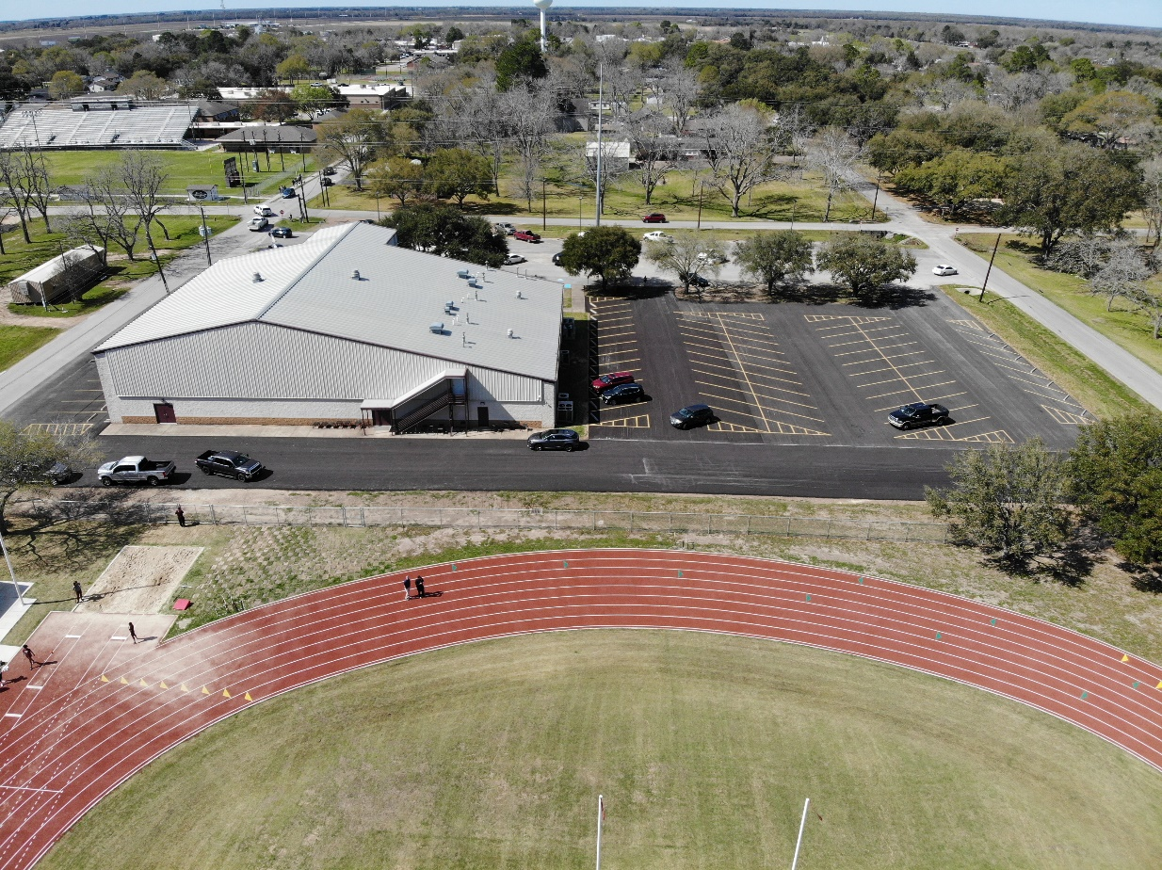

Bus Parking
Scratch Meeting/Hospitality Room

Team Camp Sites

LJ & TJ Pit 1

Pole Vault, Shot Put Rings, High Jump and Discus Rings:

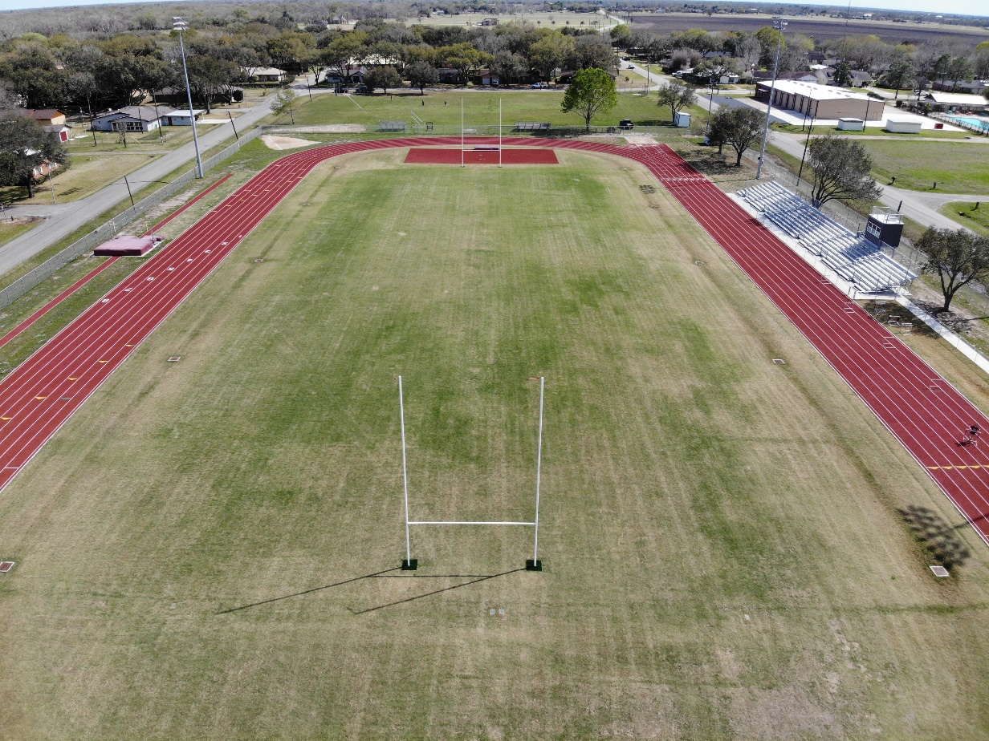
Discus Ring 1
Discus Ring 2

High Jump Pit
Shot Put
Rings 1 & 2
LJ & TJ Pit 2
Pole Vault Pit

