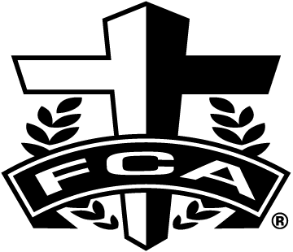
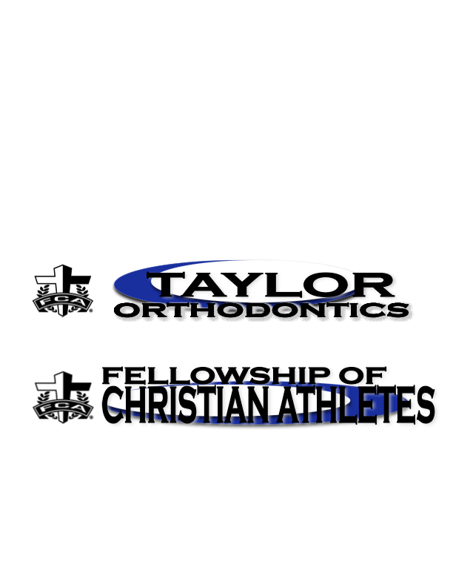
12th Annual
FCA-Taylor Orthodontics
Champions Challenge
Tuesday September 20st, 2022 @5:15 PM
at Southeast Christian Church
920 Blankenbaker Pkwy., Louisville, KY 40243
The Fellowship of Christians Athletes and Taylor Orthodontics would like to invite you to the 10th Annual Cross-Country Champions Challenge. It will be held on Tuesday, September 20st, at Southeast Christian Church. Races will start at 5:15 PM. Limited to 200 runners per division, except for 5th & 6th gr./ 7th & 8th gr. Boys & Girls will be capped at 250 with joint start time.

Registration and Information Pick up
Information pick up will begin at 4:00 PM. There will be NO Team Awards only individuals. Cost to the athlete will be $3.00 per individual, OR Coaches may enter unlimited number of runners, maximum cost per school is $100 (any questions on this, please contact us). Make checks payable to FCA and mail to: FCA, 406 Blankenbaker Pkwy., Ste. G, Louisville, KY 40243
Awards and Race Divisions
Top 5 individuals in each division will receive a medal and T-shirt, 6th place through 45th place will receive a medal. No Team awards.
Time Race/Grade Distance
5:15 PM Girls (1st and 2nd grade) 1 mile
5:35 PM Boys (1st and 2nd grade) 1 mile
5:55 PM Girls (3rd and 4th grade) 1 mile
6:15 PM Boys (3rd and 4th grade) 1 mile
6:35 PM Boys and Girls (5^{th &} 6th grade) 2 miles (capped at 250)
(separate awards)
7:00 PM Boys and Girls (7th & 8th grade) 2 miles (capped at 250)
(separate awards)

Any questions contact Steve Wigginton at 797-9532 with FCA. To register: Teams will use ky.milesplit.com to register for the meet. The meet is password protected. Contact Linda Sarrett at email or phone listed below for the password.
Linda Sarrett Steve Wigginton / FCA
(502)396-4740 406 Blankenbaker Pkwy., Ste. G
sarrettl@aol.com Louisville, KY 40243
(502)245-1514, ofc.; (502)797-9532, cell

