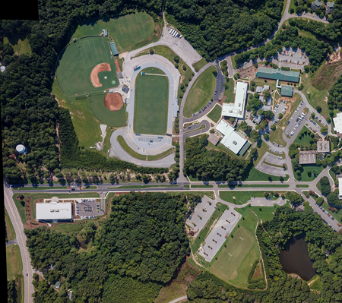
Start
Finish
Course:
2X Blue Loop
Purple Loop (around the track)
Middle School 2 Mile Course Map

