
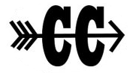
LOBO Invitational
Entry Fee Payment

The entry fee is $250 ($150 for single gender teams). Please print and complete this form for your records and return one with your payment.

Please make checks out to Rocky Mountain XC Club.

Rocky Mountain XC Club
Rocky Mountain High School
1300 West Swallow Road
Fort Collins, CO 80526

School Name: _________________________________________________

Our school is paying $250 by check for my team’s entry fee for the LOBO Invitational XC Meet.

***Payment is due by meet date, Saturday, Aug. 21, 2021.

John Prasuhn, Head Cross Country Coach
jprasuhn@psdschools.org
970-297-8620

