Fred Loya Invitational @ Eastwood High School
March 5-6th, 2021
Field Events @Eastwood
7:30 a.m. Varsity/ 10:30 a.m. JV/1p.m. 9th High Jump (Girls followed by Boys)
3 jumps only (LJ,TJ) Long Jump Boys (pit near end zone)
TJ/LJ 30m open pit Triple Jump Girls (pit near scoreboard)

8:00 a.m. Varsity/ 11a.m. JV/1:30 p.m. 9th Tripe Jump Boys (pit near end zone)
3 jumps/throws only Long Jump Girls (pit near the scoreboard)
TJ/LJ 30m open pit Boys Discus Ring @Eastpoint elementary
Girls Shot@ Eastpoint Elementary
Pole Vault /4x1600m relay @ Eastwood Friday 3/5 @1 p.m.
1pm-2:30pm -Varsity girls followed by boys
2:45-3:45pm Open girls followed by boys
4-5pm 9th girls followed by boys
Running Events (Varsity 7:30-10 a.m., Open 10:30-12:30p.m., 9th 1:00 p.m. -2:00 p.m.)
3200m 7:30am Team Assignments
4x100 relay 8am Bel Air- Pole Vault
800m Del Valle- High Jump
100h El Dorado-Shot Put
110h Burges-Long Jump
100m Montwood-Triple Jump
4x200 relay San Eli/Tornillo- Relay exchanges
400m Ysleta- Discus
300h
200m
1600m *Hospitality will be located behind the stadium
4x400 relay *Shuttle buses to Eastpoint elementary will be located on Montwood st. in front of the gym
*Each division will have a 30m transition before the next
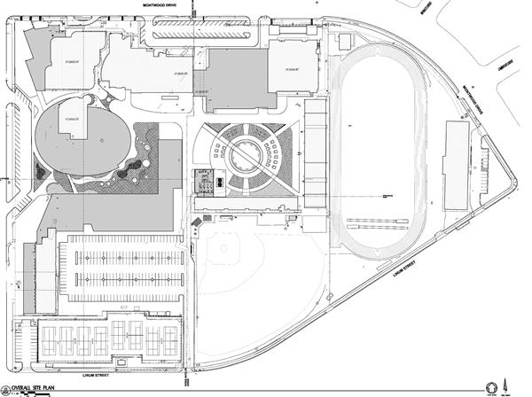
STADIUM/SECTIONS FOR CAMPS
A  BelAir/Burges | B  Del Valle/  El Dorado | C  Parent  Section | D  Parent  Section | E  Parent  Section | F  Montwood/  Ysleta | G  San Eli/  Tornillo/  Cathedral
TRACK

**Coaches please keep non-competing kids in the stadium. No camps allowed on the field
Please help clear your athletes off the venue upon the completion of that division in question.
Parents must enter through the baseball field. Athletes enter by the field house/track.

