Snook Bluejays JH Invitational
March 26, 2021
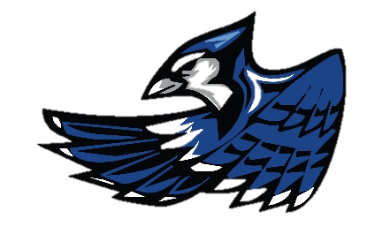
Track Meet Schedule

3:00 Scratch Meeting
3:30 Coaches Meeting
4:00 Field Events Start

B, G Pole Vault
G, B Shot Put (4 Attempts, No Finals)
B, G Discus (4 Attempts, No Finals)
B Long Jump/Triple Jump (4 Attempts, No Finals)
G Triple Jump/Long Jump (4 Attempts, No Finals)
G, B High Jump

4:30 G, B 2400 M Run

5:30 Running Events will begin at the completion of the field events.

G, B 4 x 100 Relay
G, B 800 M
G 100 M Hurdles
B 110 M Hurdles
G, B 100 M
G, B 4 x 200 Relay
G, B 400 M
G, B 300 M Hurdles
G, B 200 M
G, B 1600 M
G, B 4 x 400 Relay

