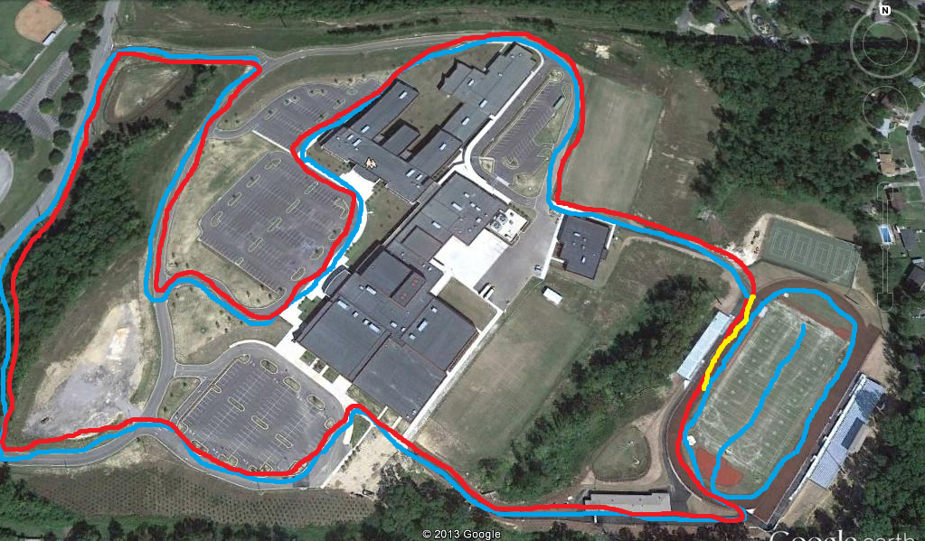

1. **Start** on Field follow **BLUE** line
2. Run down field, go around Field goal post
3. **Run 400m on track,** Exit on **Sports Complex Trail**
4. First lap blue
5. Re-enter track turn right, follow **RED** line
6. **Repeat exact route**
7. 80m Sprint to the finish line, **run through the cones, Yellow line**

**FINISH**

**START**

**Student**

**Parking Lot**

**Practice Field**

**Side Hill Road**

**Eagle Drive**

**GYM**

**Parking**

**Main Street**

**Field House Trail**

**Sports Complex Trail**